EMPLOYEE MANAGEMENT SUPPORT SYSTEM

BY

WAMBUA GIBSON MAKAU

REGISTRATION NUMBER:

P15/100586/2017

SUBMITTED: MAY 2022

SUPERVISER: ELISHA. T. OPIYO

# **DECLARATION**

I, the undesigned solemnly declare that the employee management support system is of my own, that to the best of my knowledge it contains no material published or written by another person nor material which to a substantial extend has being accepted for the award of any other degree or diploma of the university or other institute of higher learning except where due acknowledgement and references has been used or quoted.

Name: Wambua Gibson Makau.

Signature: ………………………………… Date: ……………………….

Supervisor: Elisha Toyne Opiyo.

Signature: ………………………………… Date: ……………………….

# **ACKNOWLEDGEMENTS**

I take this opportunity to acknowledge some of the people who have made a major contribution to the development of this project.

My supervisor, Dr. Elisha Toyne Opiyo for the guidance throughout the project and the reviews, suggestions and support. He gave me the opportunity to do this project and making this project what it has come out to be.

My almighty God, who gave me the insight and passion to accomplish this work. My parents for their full support and my siblings for their helpful suggestions.

Members of staff at the Department of Computing and Informatics for the assistance through their experiences in database and web advanced technologies such as php and sql.

Finally, my fellow classmates for the insightful ideas and the user interface outlook of the system and his moral support.

# **DEDICATION**

I dedicate this work to my parents. The two people that gave me the tools to be where I am standing today. I look back on my life, the lessons I have learned and the guidance they gave me. I also dedicate it to my almighty God, the source of my inspiration, wisdom knowledge and understanding. Also, to Dr. Boniface Kiteme for the encouragement and guidance. My supervisor Dr Opiyo for his dedicated time and the directions he gave me for the accomplishment of this project.

# **ABSTRACT**

Employee management system combine number of processes and systems to automate and easily manage employee data, leave request, track and grant leave and Employee key Documents storage and retrieval. In many institution staff are entitled to different types of leave, these leaves are granted according to institution policy. Administrative department is mostly responsible for managing and granting leave request. To this end, most institution used conventional method of requesting, granting and managing leave. In conventional method, leave is manually request by writing letter to head of department. The head of department minutes and forward the request to higher staff for approval. This method is time consuming, prone to error, require more paper work and difficult to manage. Hence the need for an automated leave management system that is faster, error free, less paper work and easy to manage. The Administrative planners also need to know how many people work for him or her, who they are, where they are and their qualifications. Existing manual file handling technique is prone to errors such as misplacement of documents and loss or tearing of the documents. Personnel records provide a basis for decision making in every area of personnel work. To facilitate better file handling system for employees, an automated file storage and retrieval of documents is needed for faster decision making and updating of the employee’s detail.

There have been solutions to this problem such as the use of online based storage of employee documents and systems such as calamari, a cloud-based human resource management which is premium and costly to purchase. These systems work well but at a high expense of purchasing them by an organization.

This System created is implemented using web-based technologies which include CSS, JS, HTML, MySQL, PHP and runs on Windows, Linux or Mac operating systems. A flexible and easy to use Employee Management support software solution for small and medium sized organization to provide modules for personnel information management and leave management thereby organization and companies are able to manage the crucial organization asset – people. The system functions on any browser.

The overall functionality of the system shows that it works satisfactory and the result obtained shows that the system is error free, faster and allows staff to request for leave in a timely manner and access their key documents and data. Hence the system can be used by both academic staff and administrative department of an institution for effective and efficient management of employee leave and documents.

The system in the future can be incorporated with payroll system that will enable employees to view and download their pay slips on demand. Attendance management to keep track of present and absent employees. Employee performance system where employees are assigned tasks individually or as a group and a rating system of the employees to improve morale.

Table of Contents

**DECLARATION** 1

**ACKNOWLEDGEMENTS** 2

**DEDICATION** 3

**ABSTRACT** 4

**1 CHAPTER 1: INTRODUCTION** 8

**1.1 PROJECT BACKGROUND** 8

**1.2 PROBLEM STATEMENT** 8

**1.3 AIM** 9

**1.4 OBJECTIVES** 9

**1.5 SCOPE** 10

**1.6 SIGNIFICANCE OF THE STUDY** 10

**2 CHAPTER 2: LITERATURE REVIEW** 12

**2.1 Introduction.** 12

**2.2 Employee Management support system.** 12

**2.3 Review of related Systems** 14

**2.3.1 OrangeHRM** 14

**2.3.2 sumHR** 15

**2.3.3 WebHR** 15

**3 CHAPTER 3: METHODOLOGY** 17

**3.1 Software Methodologies** 17

**3.2 Development Tools** 18

**3.21 Back-end Technologies.** 18

**3.2.2 Front-end Technologies.** 18

**4 CHAPTER 4: SYSTEM ANALYSIS** 20

**4.2 REQUIREMENTS AND CONSTRAINTS** 20

**4.2.1 Functional Requirements.** 20

**4.2.2 Non-Functional Requirements.** 22

**4.3 USE CASE ANALYSIS** 22

**5** **CHAPTER 5: SYSTEM DESIGN** 27

**5.1 System and algorithm flowcharts** 27

**5.2 Entity Relationship Diagram** 28

**5.3 PROCESS FLOW DIAGRAM.** 29

**5.4 Data flow Diagram** 31

**5.5 SUMMARY** 32

**6 CHAPTER 6: IMPLEMENTATION AND TESTING** 33

**6.1 Introduction** 33

**6.2 System installation.** 33

**6.3 Pseudocodes.** 34

**6.4 Screenshots of Developed system.** 35

**6.5 System Testing.** 36

**7 REFERENCES** 38

**8** **APPENDIX** 41

**Sample Codes:** 41

**Database connection:** 41

**Download Documents:** 41

**Employee login authenticate:** 42

**Add an employee:** 42

**Add document:** 45

**Developed system snapshots:** 46

**System Homepage:** 46

**System Contact page:** 47

**Employee login page:** 47

**Manager Login page** 48

**Employee User Interface:** 49

**Manager User Interface:** 55

Table of Figures

Figure 1: uml diagram employee management support system. 21

Figure 2: OrangeHRm 22

Figure 3: SumHR 23

Figure 4: WebHR. 24

Figure 5: Iterative Waterfall Model. 25

Figure 6: employee use case diagram. 33

Figure 7: manager use case diagram. 34

Figure 8: Activity diagram for leave application 35

Figure 9: Activity diagram for leave Acceptance / Rejection 36

Figure 10: Entity relationship diagram. 37

Figure 11: process flow diagram 39

Figure 12: data flow diagram. 39

Figure 13:System Homepage 54

Figure 14: System contact. 55

Figure 15: Employee login. 55

Figure 16: Manager login. 56

Figure 17: Employee login Homepage. 57

Figure 18: Employee myprofile. 58

Figure 19: Employee update my profile . 59

Figure 20: Employee download my documents . 60

Figure 21:Employees’ change password . 60

Figure 22: Employee Apply leave 61

Figure 23: Employee Leave History. 62

Figure 24: Manager Login homepage. 63

Figure 25: Manager view employees. 64

Figure 26: Manager Edit an employee information. 65

Figure 27: Manager Reset employee login password. 66

Figure 28: Manager add an employee. 67

Figure 29: Manager employee documents 68

Figure 30: Manager add employee documents. 69

Figure 31: Manager view pending leaves. 70

Figure 32: Manager view leave history. 71

Figure 33: Manager view leave history per employee. 72

Figure 34: Sample leave report. 73

# **1 CHAPTER 1: INTRODUCTION**

## **1.1 PROJECT BACKGROUND**

Manual Handling of employee information poses a number of challenges. This is apparent in procedures in procedures such as leave management where employee is required to fill a for which may take several days or weeks or months to be approved or the document handling of personnel files where a personnel’s documents on being authenticated copies are made and stored in cabinets which is tedious. Convenient manual handling of papers could lead to human errors, papers may end up in the wrong hands or wrong file and the fact that its’s time consuming. A number of current systems lack employee self-service platforms whereby they can’t access and manage their personal information directly without going to their managers. In Kenya some institutions handle employee’s information manually by use of papers. It becomes a hectic job for the managers to handle employee information and needs and the current systems are mostly costly.

A flexible and easy to use employee management support software solution for small and medium sized companies provides modules for personnel information management thereby organization and companies are able to manage the crucial organization asset, employees. The project is aimed at setting up employee information system to handle leave requests and key employee document accessing and retrieval to orderly monitor leaves and employee’s leave reports through a password protect system.

## **1.2 PROBLEM STATEMENT**

Some companies in Kenya still handle employee information manually. Leave management and employee’s documents storage is a hectic job when handling manually and prone to lots of errors. As to why the companies don’t have the systems to handle this, it takes time and effort to implement these systems. Self-service systems must always be subordinate to the employee’s needs. Provide support instead of ultimatums. In Kenya technology is still advancing and the current managers, some of them are not to the current state of technology to advance their companies employee efficiency. The managers may lack the personnel to implement the system and updating it often.

An employee management support system solves the need in an organization to maintain employee information in a database ensuring full privacy to each employee. It will help the manager in faster decision making due to fast retrieval of employee documents.

## **1.3 AIM**

To develop an employee management support system including: Leave management, document handling and leave report generation.

## **1.4 OBJECTIVES**

Project planning; Provide a complete time schedule of all tasks to accomplish.

Project requirements review; The requirements will change overtime and implemented to the system.

Give a concise description of the functionalities the system will implement e.g., how to check if a user is logged in and if not, deny access and redirect to login module.

Design a simple and easy to use system which is user friendly and easy to adapt.

Use of coding standards to make it easier in detecting errors, easy maintenance and generate faster results. Focusing of code readability and use of comments to guide readers through the algorithms and logic implemented.

Affirm the full integration of the system and test all functionalities work. Module such as leave management, manager gives a reason as to why the leave was rejected.

Deployment of the system online; the system can be accessed online and without errors.

## **1.5 SCOPE**

Project scope will be limited to the following:

Employee profiles:

The employees will be able to access their personal information and will be able to edit and update their details and change their password.

Employee electronic Leave Processing:

Complete elimination of paperwork in leave management by enabling an employee apply for leave as well as check their leave status through the system. This will also enable the HR manager to accept/reject leave application through the system and the reason to why rejected.

Employee Document management System:

Eliminating file desks to store employee files enabling for the manager to access files rather quicker. The employees can as well download the files. The files are uploaded by the manager on authentication that they are Legit.

Registration of new employees:

The manager is able to add new employees and create a default password and employee id. HR manager has the ability to add an employee’s information to the database.

Generate Leave reports:

The user is able to get his/her leave report. The manager as well can generate leave report for a user as well as the leave report of all employees combined.

## **1.6 SIGNIFICANCE OF THE STUDY**

This project is made with the aim to be user friendly and offer easy access to data and services such as leave management, leave reports and employee documents handling.

The employee will interact with the system through a password protected user account and once logged in, he/she can apply leave, view his/her documents, update his details and generate leave reports. This is essential as it will save time opposed to manual handling of the services. The system is web-based so it can be accessed anywhere hence convenient for the employees. This direct interaction of the system will enable employee self-service.

The manager can keep track of employee’s information, manage leave and view employees’ personal documents at the click of a button. The manager can make decisions faster due to a faster retrieval of employee documents. Manager can make fast decisions to a leave request upon viewing previous leave history of an employee. The tedious job of handling all the above is automated and made easier for the managers.

# **2 CHAPTER 2: LITERATURE REVIEW**

## **2.1 Introduction.**

This chapter consists of what scholars and authors have written about human resource management systems, basic weaknesses and strengths and their thoughts over various objectives of designing the systems.

Human resource management include all management decisions and practices that affect the employee of an organization.

Human resource management is considered to be the most important factor that helps the organization to achieve a competitive advantage (Obeidat, 2014). This is due to the fact that managers in both public and private organizations consider human resources to be the main source of sustaining competitive advantage; this is done by having the “best of the best” human resource systems for recruiting, selecting, motivating, and efficiently managing their people.

## **2.2 Employee Management support system.**

Management is not only about managing resources and controlling expenses even though they are the basic functions of management. Key important management function is the ability to manage employees as they are the lifeline of the company. The state of the current country economy is dauting leading to many companies’ laying-off employees. However, there are some companies that have capitalized on the downtown of the economy to reduce overhead costs and increase employee productivity even if the need does not exist.

An organization or company with a very large number of employees manages a greater volume of data. This activity can be daunting without a more sophisticated tool to store and retrieve data. The various levels of sophistication can be examined by looking at the evolutionary aspects of Human Resource technology. The development is in four stages: Paper-based systems, early personal computer (PC) technology, electronic databases, and Web-based technology. Today’s focus is automating as many transactions as possible to achieve effectiveness and efficiency.

This new system will not only reduce the number of human resource staff but also increase the efficiency of the staff. The system will help the manager in decision making. The Hackett Group, an advisory firm did a study and found that high-performing organizations spend 33 percent less on costs then the peer human resource organizations and 11.6% less than traditional world-class human resource organizations.

The system manager who is the administrator is able to log in and the system authenticates his/her login. Upon logging system, he/she can add or edit employee particulars, upload and download employee documents, leave management and view leave reports. The employee has the right to view and change few of his/her details as well as login details, apply leave and generate his/her leave report and download his/her documents.

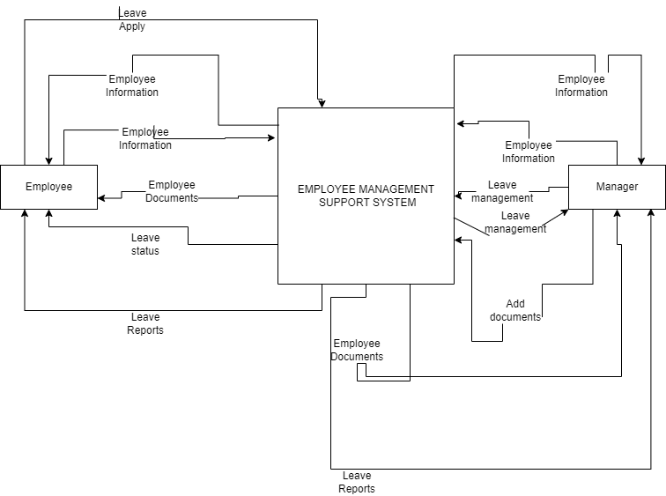

Figure 1*: uml diagram employee management support system.*

## **2.3 Review of related Systems**

### **2.3.1 OrangeHRM**

It’s an open-source Human Resource Management system. One can host the system on a hardware or buy a hosted solution. This system benefits small or mid-sized businesses. The system can be installed on any platform, Windows, Linux or Mac and has an installation guide.

OrangeHRM’s main features include: Administration module, Personal information management, Leave Module, Time Module, Employee self-service module, Recruitment tracking module and Performance module.

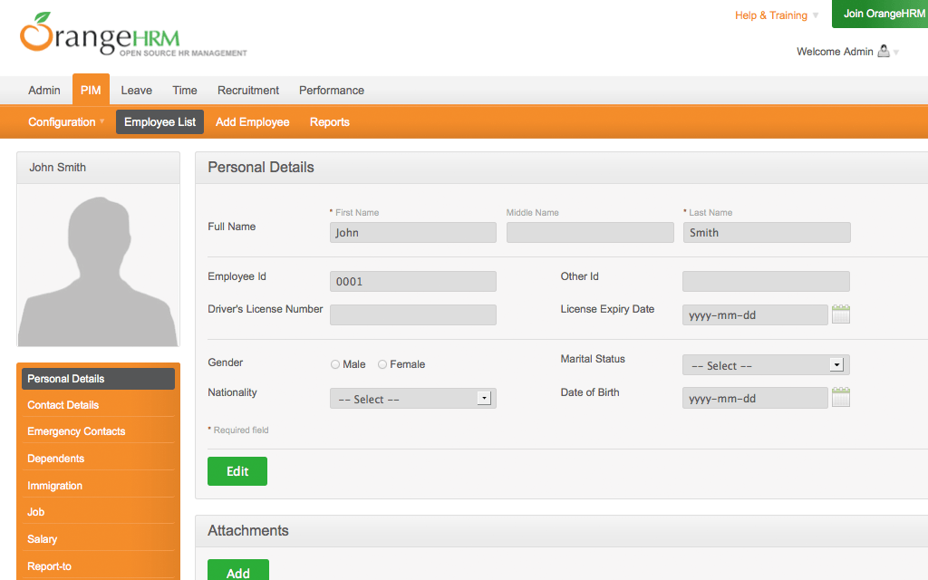

Figure 2: OrangeHRm

### **2.3.2 sumHR**

sumHR is online based Human Resource management system. It does have a 7-day free trial then after one has to pay for the system. The system is set up on sumHR server which in then can be accessed online if one has an account.

Its main features include: Realtime attendance tracking, leave tracking, payroll processing, Human resource analytics and employee information management.

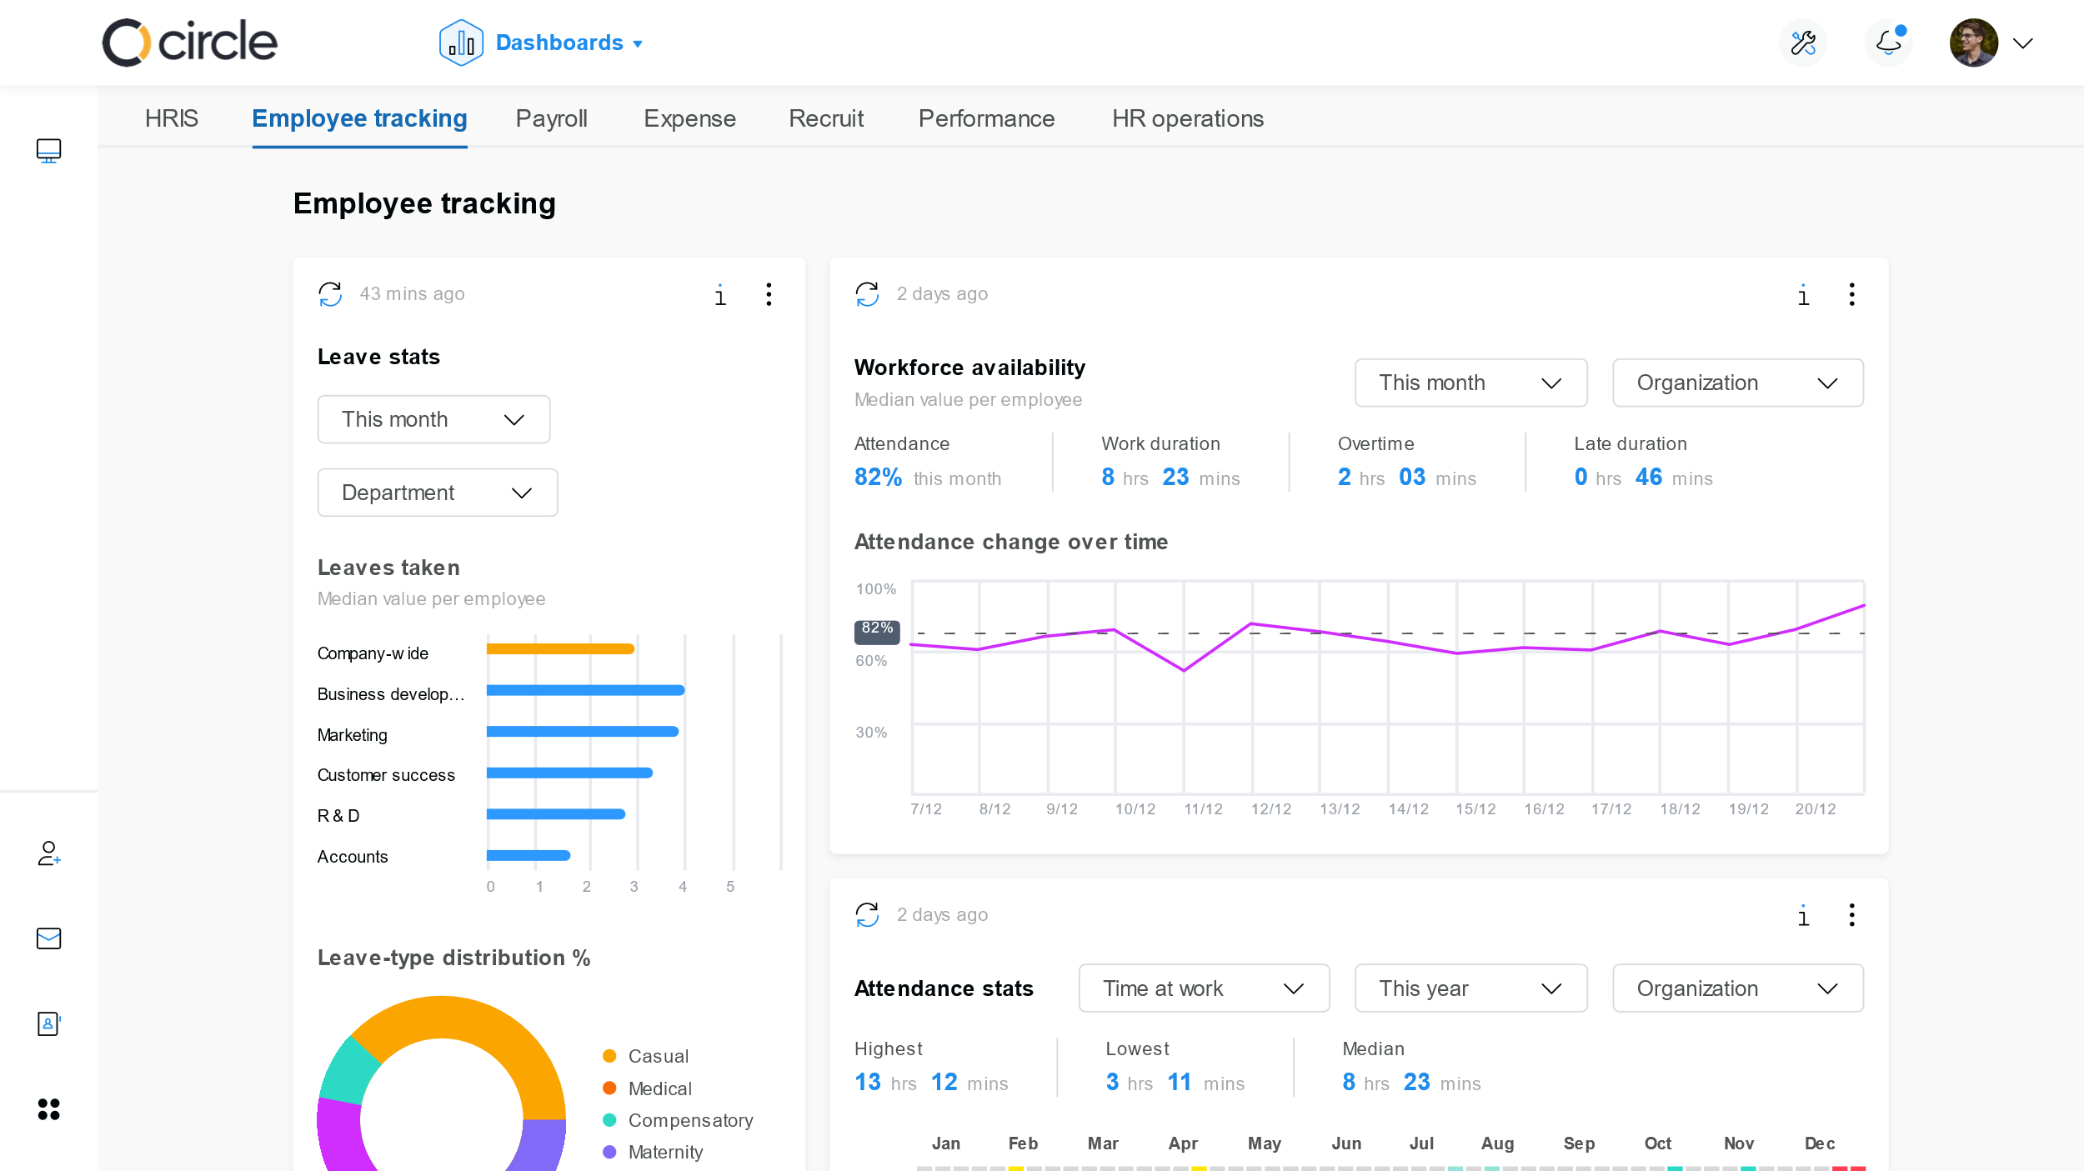

Figure 3: SumHR

### **2.3.3 WebHR**

WebHR is an integrated human resources platform designed to help businesses with all aspects and processes of Human Resource management. The system is built to cover every base of their employees’ journey from “hire to retire”. The system consists of plans, free or paid premiums and is a web-based system.

Its features include: Time Tracking system, Recruitment performance, report, electronic signature and Payroll.

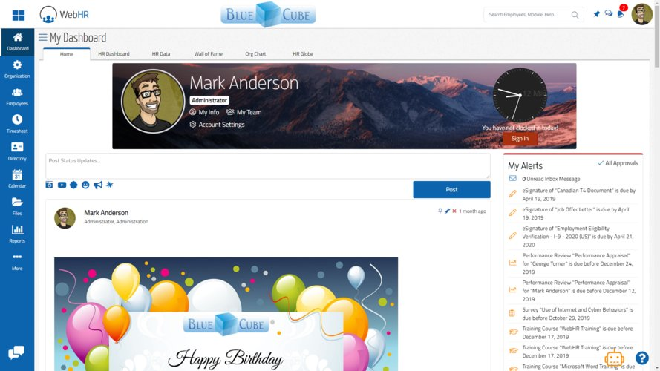

Figure 4: WebHR.

# **3 CHAPTER 3: METHODOLOGY**

## **3.1 Software Methodologies**

The Waterfall Model.

The waterfall model is a sequential design process, often used in software development processes. In practice, it is not possible to strictly follow the classical waterfall model for software development work. In this context, we can view the iterative waterfall model as making necessary changes to the classical waterfall model so that it becomes applicable to practical this software development projects.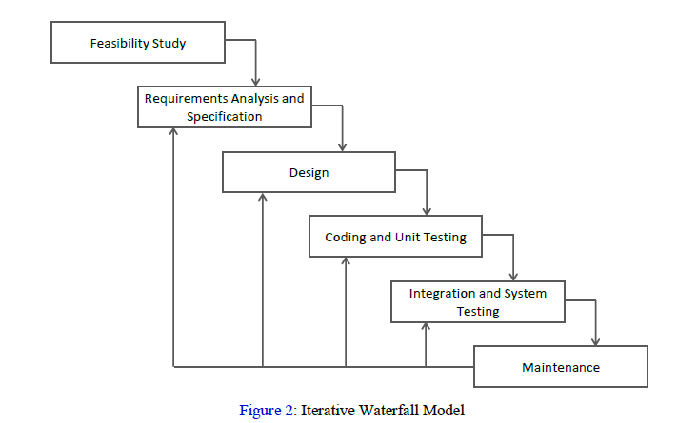

Figure 5: Iterative Waterfall Model.

This model allows the mechanism of error connection because there is a feedback path from one phase to its preceding phase which it lacks in the Waterfall Model. As the development proceeded, errors occurred such as storing of the employees’ documents being duplicate so needed to go back to design and use different approach.

## **3.2 Development Tools**

### **3.21 Back-end Technologies.**

#### **PHP**

Hypertext Preprocessor is a server-side scripting language that is used for web development. It can be easily embedded with HTML files. HTML codes can also be written in a PHP file. The PHP codes are executed on the server-side whereas HTML codes are directly executed on the browser.

#### **MYSQL**

MySQL server is an open-source relational database management system which is a major support for web-based applications. Databases and related tables are the main component of many websites and applications as the data is stored and exchanged over the web. MySQL server is used for data operations like querying, sorting, filtering, grouping, modifying and joining the tables. It is non-proprietary, easily extensible and platform independent. Its downside is that it lacks a graphical user interface therefore, you need to know how the database works to make the most efficient use of it.

### **3.2.2 Front-end Technologies.**

#### **HTML**

Hypertext Markup Language. It is used to design web pages using the markup language. HTML is the combination of Hypertext and Markup language. Hypertext defines the link between the web pages and markup language defines the text document within the tag that define the structure of web pages. HTML is used to create the structure of web pages that are displayed on the World Wide Web (www). It contains Tags and Attributes that are used to design the web pages. Also, we can link multiple pages using Hyperlinks. It has some low-cost benefits due to its many free online tutorials and advice support which is vital for m-commerce development.

#### **CSS**

CSS is a style sheet language used to describe presentation and layout of HTML tags. CSS helps us achieve layout design and control much easier.

#### **JAVASCRIPT**

JavaScript is a lightweight, interpreted, object-oriented language that is browser based and was developed by Netscape to enable web masters/authors to add interactivity and enhances behavior of web pages. JavaScript runs on the client side of the web.

# **4 CHAPTER 4: SYSTEM ANALYSIS**

At Wamwalimu Hardware organization where the business employs about 43 people, The manager is faced with problems when granting leaves and the documentation. He needs

## **4.2 REQUIREMENTS AND CONSTRAINTS**

### **4.2.1 Functional Requirements.**

**Leave Management**

Leave application: The employee is able to fill in leave application form in the appropriate fields. Upon rejection or approval, the user shall view the leave status and the manager decision or say to why the leave is rejected or approved.

Leave Approval: The manager is able to approve leave applications based on the leave reasons stated and length of the leave.

Leave Rejection: The manager is be able to reject a leave and state a reason as to why the leave was rejected.

Leave history: An employee is able to view his/her leave history. The manager is also able to view leave history of all employees and also a single employee leave history.

**Authentication**

Login: The user can login to the employee management system with her/his email and password.

Logout: The user can log out of the employee management system or be logged out if there is no user activity on the system for a period of 5 minutes.

Login Failure: In the occurrence the user is not in the system or entered the wrong credentials required to login to the system.

**Authorization**

Users’ credentials are validated and on success redirected to a user home page according to their roles in the system.

**Document Handling**

Employees are able to view their personal documents.

Manager can view the employee documents, add new documents and delete documents.

**Data Processing**

Display: User with defined roles can display the content of the database. An employee can only view his/her personal information and documents. The manager can see all the employees’ documents and personal information.

Edit: Manager can edit all user all information and documents related to all employees. Employees’ can edit their specific personal information.

**Recruitment**

Add new employee: Manager role type is able to add a new employee to the database. The new employee will have all the required personal information and documents related to him/her. The new created employee will have a unique id generated by system.

**Report Generation**

An employee can acquire a report of his/her leave history. The manager is able to generate overall leave report and a single employee leave report. The reports are generated in pdf format.

### **4.2.2 Non-Functional Requirements.**

**SOFTWARE REQUIREMENTS:**

1.Xampp or Wamp software’s.

2.Browser.

**HARDWARE REQUIREMENTS**

The Employee management system should be able to work with the following minimum hardware specifications:

OS: Windows XP/Vista/7/8 and Linux.

Memory: 128 MB and above.

CPU: Pentium III (700MHz) and above.

Capacity: 4GB of hard drive.

Others: Network interface card, mouse, keyboard, and monitor.

**PERFORMANCE REQUIREMENTS**

There is no restriction to the number of users added to the system.

## **4.3 USE CASE ANALYSIS**

A use case is a list of actions or event steps, typically defining the interactions between a user and a system, to achieve a goal.

The actors are:  
1. Employee

2. Manager

|  |  |  |
| --- | --- | --- |
| **ACTOR** | **USE CASE** | **DESCRIPTION** |
| Employee | Edit profile | Employee will be able to edit personal details such as contact number, emergency contact number, address, province and email and also view his details. |
| Employee | Apply leave | Employee will be able to submit leave request along with the reason as to the leave as well as view if approved or rejected and the reason for rejection. |
| Employee | Download documents | Employee will be able to download his/her documents. |
| Employee | Generate Report | Employee will be able to generate his/her leave report. |
| Manager | Edit employee’s profiles | Manager is able to edit all employees’ data. |
| Manager | Add new employee | Manager will be able to add new employees. |
| Manager | Leave management | Manager will be able to accept leave applications, or reject leave and provide a reason as to why reject the leave and also view leave history of the employees. |
| Manager | Document handling | Manager will be able to add documents per employee and also view the documents when in need. |
| Manager | Generate report | The manager is able to generate leave reports, per employee or all employees leaves. |
| Manager | View all employees | The manager is able to view all employees’ profiles. |

Employee use case diagram:

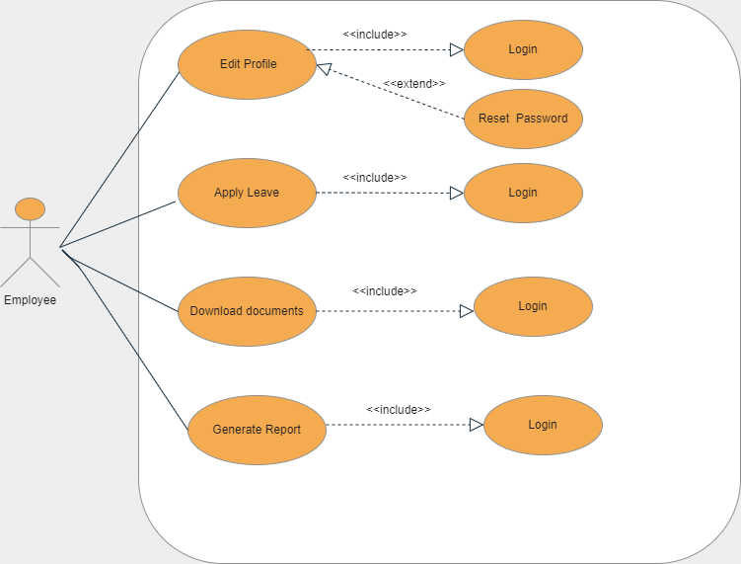

Figure 6*: employee use case diagram.*

Manager use case Diagram:

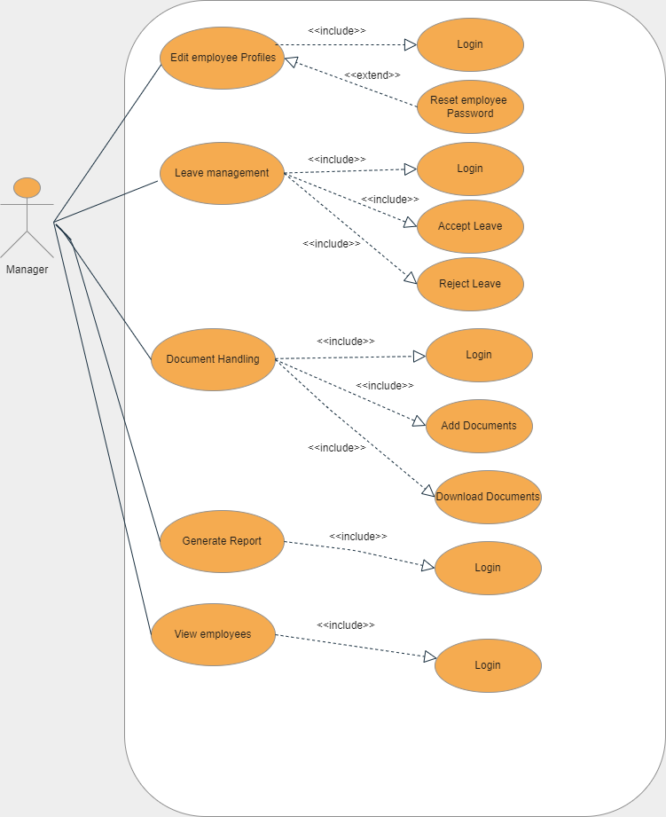Figure 7*: manager use case diagram.*

# **5** **CHAPTER 5: SYSTEM DESIGN**

## **5.1 System and algorithm flowcharts**

The following activity diagram is used to model the leave application function.

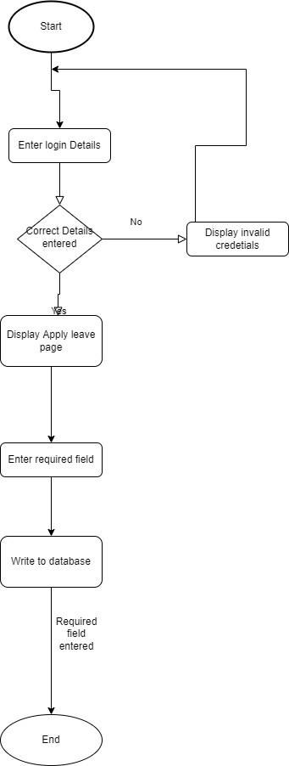

Figure 8*: Activity diagram for leave application*

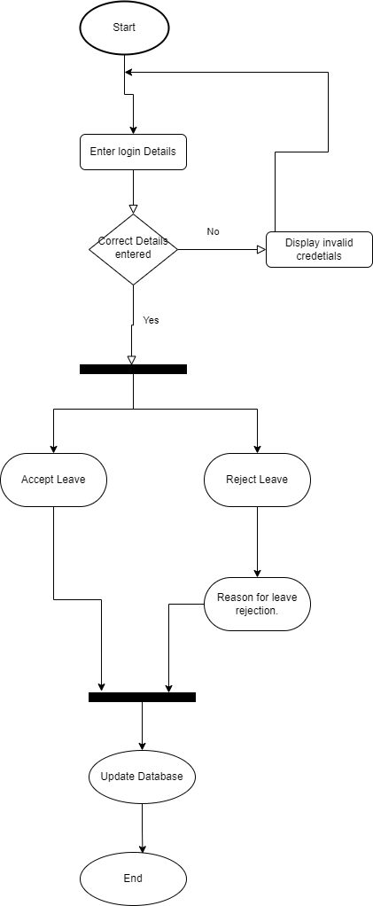

Figure 9: Activity diagram for leave Acceptance / Rejection

## **5.2 Entity Relationship Diagram**

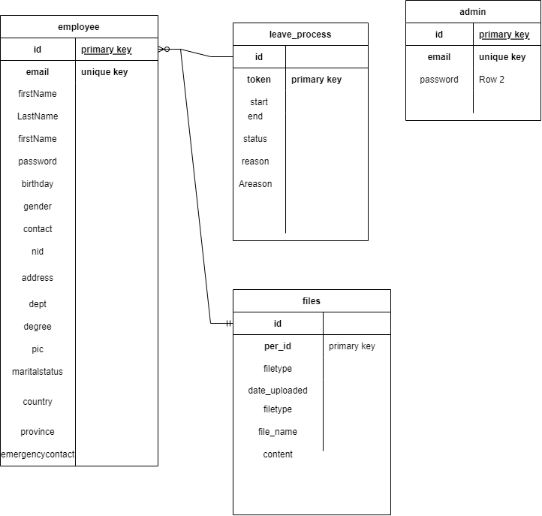

Figure 10*: Entity relationship diagram.*

## 

## **5.3 PROCESS FLOW DIAGRAM.**

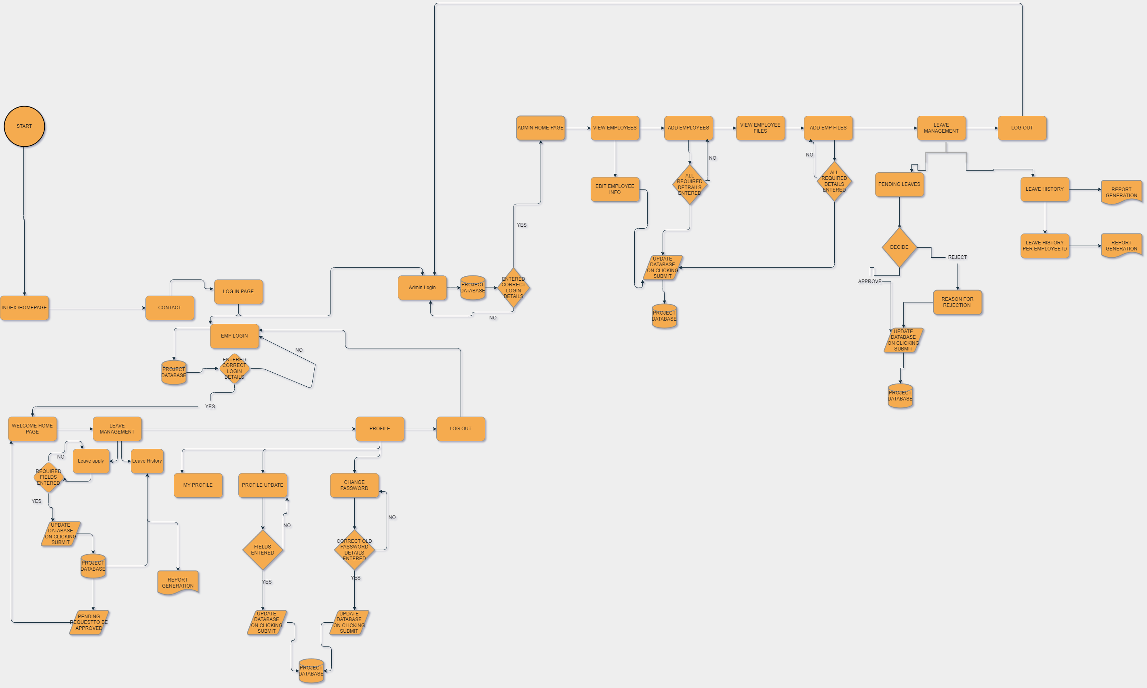

Figure 11: process flow diagram

## **5.4 Data flow Diagram**

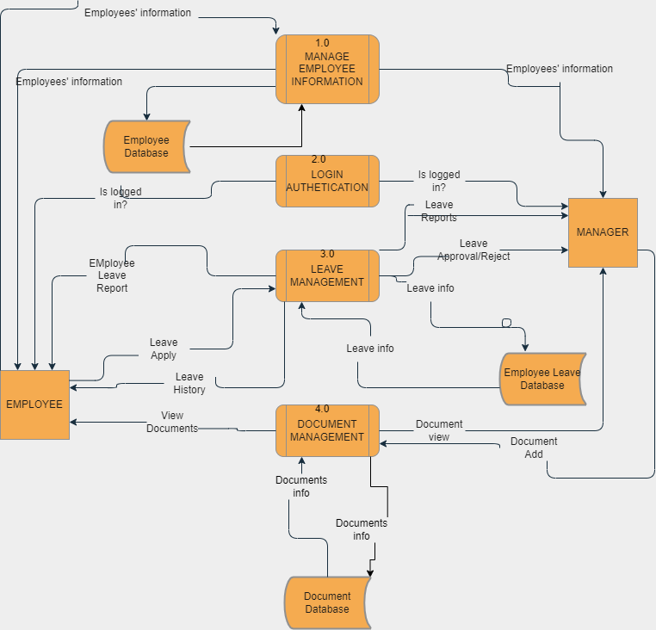

Figure 12*: data flow diagram.*

## **5.5 SUMMARY**

This Chapter has specified the design of the Employee Management System. The aspects of the design that have been discussed are system design, and database design by providing the data flow diagram and entity relationship.

# **6 CHAPTER 6: IMPLEMENTATION AND TESTING**

## **6.1 Introduction**

The developed system encompasses the implementation of the functionalities defined.

The system can only be accessed by the employees and the manager.

All users are represented with the same login interface. User must login the system by means of valid username and password combination. After access is granted, the user is redirected to a homepage.

The employee can view his/her profile and update basic information i.e., email, emergency contact, contact, address and province. Employees can apply for leave by filling in a form and submitting it. He/she then views the leave history to view the status of the leave and also generate a leave report. The employee is also able to change his password.

The manager can view and edit and delete an employee’s information. The manager is also able to add a new employee and the employee’s documents. The manager approves leaves or rejects them and gives a reason to why the leave was rejected. The manager accesses all employees leave history and also view a single employee leave history. Manager has the ability to generate all employee’s leave report and also single employee leave report.

## **6.2 System installation.**

The system was developed and tested on a laptop computer running Windows 11, and the XAMPP Server. In order for the Web application to be accessible via the Internet it will have to be installed on a Web Server running Apache, PHP and MySQL. The suitable operating system for the web server will be Linux as it is more stable and less prone to virus but a windows-based platform will equally do the job just as well. The system can be connected to work on other computers via LAN or host the website via a company of choice, free or pay a web hosting company. The web application will be accessible via most of the popular web browsers on the market. A suitable web browser e.g., Microsoft Edge or Mozilla Firefox will have to be installed on the client machine wishing to access the web application.

## **6.3 Pseudocodes.**

*Add new Employee:*

*Check if administrator is logged in*

*If correct*

*Check if all details are entered*

*If not*

*System message: Please fill out this input field*

*If yes*

*Registration of a new employee successful.*

*Apply leave application:*

*Check if employee is logged in*

*If correct*

*Check if all details are entered*

*If not*

*System message: Please fill out this input field*

*If yes*

*Leave Request Has being made*

*Log into the system employee:*

*Startup system*

*Employee Login page*

*Enter username and password*

*On clicking the login button*

*Connect to database*

*Query database to know whether user credentials are correct*

*If not*

*Deny access and return login page with an error message invalid credentials*

*If correct*

*Check if credentials are for that employee*

*If yes*

*Allow login*

*Set employee id as the session*

*Redirect employee to the employee homepage.*

*Log in to the system manager:*

*Startup system*

*Login page*

*Manager login page*

*Enter username and password*

*On clicking the login button*

*Connect to database*

*Query database to know whether user credentials are correct*

*If not*

*Deny access and return login page with an error message invalid credentials*

*If correct*

*Allow login*

*Set manager email as session*

*Redirect administrator to manager homepage*

*Add employee documents:*

*Check if administrator is logged in*

*If correct*

*Check if all details are entered*

*If not*

*System message: Please fill out this input field*

*If yes*

*Document added successfully.*

## **6.4 Screenshots of Developed system.**

Refer to Appendix for screenshots of the developed system.

## **6.5 System Testing.**

|  |  |  |  |  |
| --- | --- | --- | --- | --- |
| **Test case ID** | **Scenario** | **Test condition** | **Expected Result** | **Actual Result** |
| 1. | Login | User must enter all fields and enter the correct login details and if error display invalid credentials. | User is granted access to the main system on submitting all correct necessary details. | Successful log in to the system per user upon correct submission of login credentials. |
| 2. | Apply Leave | Employees can apply for leave and check leave status and is logged in and manager can approve or reject the leave stating the reason as to why the leave was rejected. | Employee can apply for leave stating the reason and the leave displayed in the manager panel for processing showing number of the leave days and manager can approve the leave or reject it stating a reason as to why. | Leave request is submitted and a success message is displayed and the leave shown in manager panel for approval or rejection and stating the reason to why rejecting the leave. |
| 3. | Edit details | Employees can edit a selected few details and altered in the database and manager can edit and view all user details if and only the user has logged into the system. | When the form is altered the details are altered in the database. | When the data in the form is altered and the update button is clicked the database details are altered. |
| 4 | Document handling | Manager can add or delete employee documents and also download them and the employee can also download the documents. | The manager can add a document showing who the document belongs and only that employee can download that document. | Each employee can download their documents and no other employee can access document that is not theirs and manager can add employee documents depicting the document belongs to which employee and also can download any employee documents. |
| 5. | Add new employee | Ensures a new employee is added to the system successfully. | All required fields of a new employee are added and an employee id issued by the system and a picture of the employee uploaded. | New employee is added successfully. |
| 6. | Leave report Generation | Manager can generate leave reports per user or the overall leave report and an employee can generate his/her leave report. | On clicking the link of choice of the report generate report should be displayed or downloaded in the format of pdf format. | Report is displayed or downloaded |

# **7 REFERENCES**

1. John Barneson (2016). Human Resource management. Last accessed May, (2022).
2. Bader Obeidat (2014), Ayman Bahjat Abdallah(2014), Ra'Ed Masa'deh (2014). The Relationships among Human Resource Management Practices, Organizational Commitment, and Knowledge Management Processes. Last accessed March, 2022.
3. Orange HRM (2022). OrangeHRM Human Resource management. URL:

<https://sourceforge.net/projects/orangehrm/> Last accessed, May,2022.

1. The Hackett Group (2021). The Hackett Group New Digital World class standards Raise the bar on Human Resource Performance. URL:

<https://www.thehackettgroup.com/news/human-resources-organizations-can-achieve-breakthrough-improvements-by-embracing-digital-technology/> Last accessed, May,2022.

1. Wikipedia (2014). Employee Self Service. URL:

<http://en.wikipedia.org/wiki/Employee_self-service_%28web-based_application%29> Last accessed, April,2022.

1. Calamari (2022).HR innovations you will love.URL:

<https://calamari.io/> Last accessed, March,2022.

1. Geeksforgeeks (2021). PHP Manuals. URL:

<https://www.geeksforgeeks.org/php-tutorials/> Last accessed, April,2022

1. PHP (2022). PHP Manual. URL:

<https://www.php.net/manual/en/index.php> Last accessed, April,2022.

1. Geeksforgeeks (2021). Web Development practices, URL:

<https://www.geeksforgeeks.org/web-development/> Last accessed, March,2022

1. SumHR (2022). Employee Management system for startup. URL:

<https://www.sumhr.com/blog/employee-management-system-startupssmbs-free-worries> Last accessed, February,2022.

1. WebHR (2022). Cloud Based All-in-One Social Human Resource Software, URL:

<https://reviews.financesonline.com/p/webhr/> Last accessed, March, 2022

1. Medium (2019). Why and what is employee management system. URL:

<https://medium.com/@akhiltaneja05/employee-management-system-why-and-how-to-start-using-one-a65414ecd707> Last accessed, March,2022.

# **8** **APPENDIX**

## **Sample Codes:**

### **Database connection:**

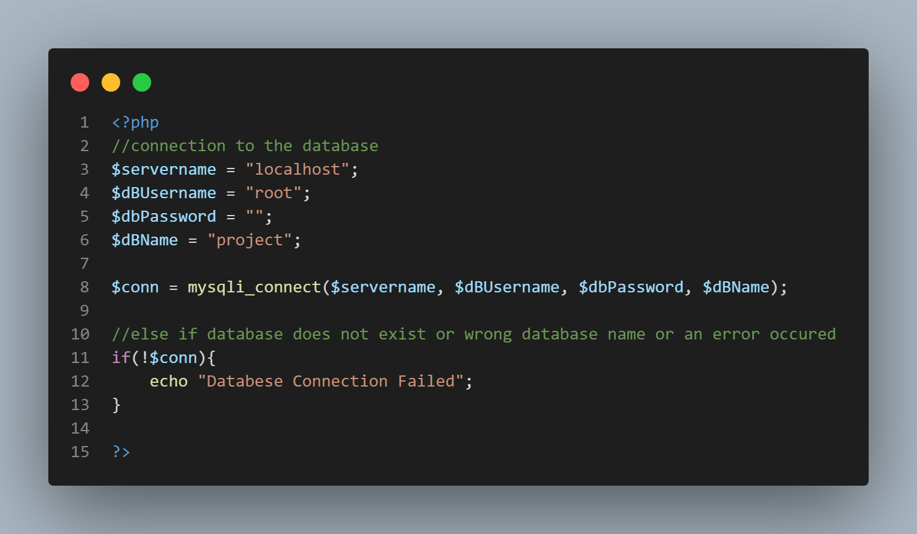

### **Download Documents:**

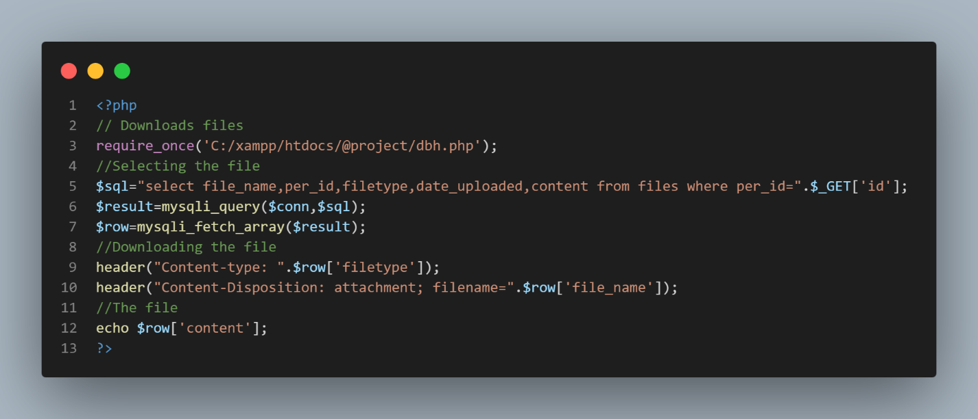

### **Employee login authenticate:**

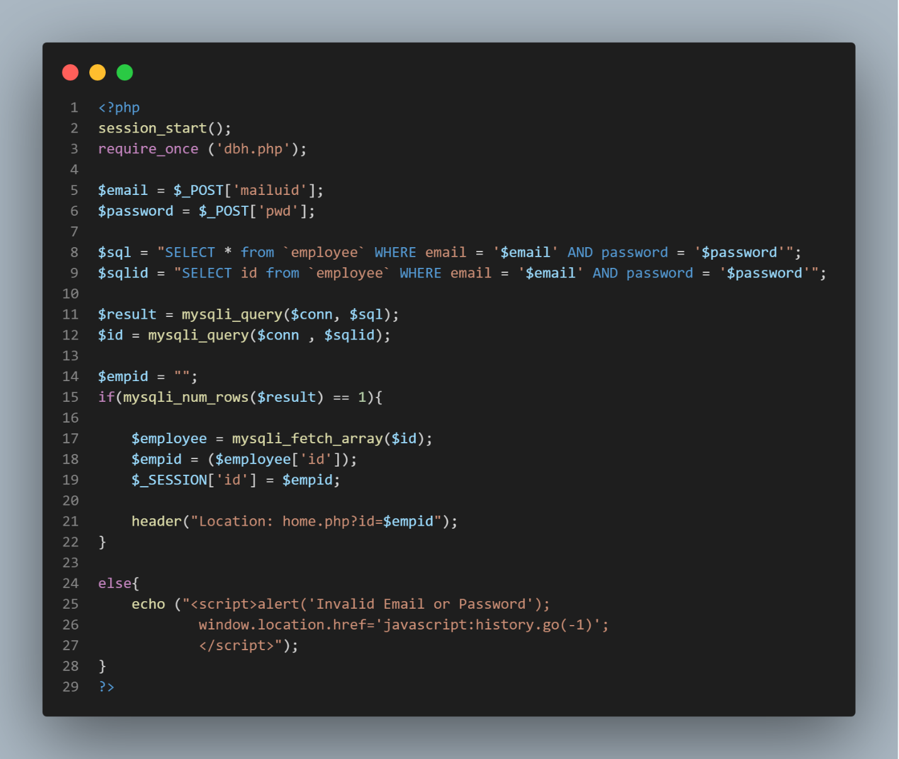

### **Add an employee:**

<?php

require_once ('C:/xampp/htdocs/@project/dbh.php');

$firstname = $_POST['firstName'];

$lastName = $_POST['lastName'];

$email = $_POST['email'];

$contact = $_POST['contact'];

$address = $_POST['address'];

$gender = $_POST['gender'];

$nid = $_POST['nid'];

$dept = $_POST['dept'];

$degree = $_POST['degree'];

$maritalstatus = $_POST['maritalstatus'];

$birthday =$_POST['birthday'];

$country = $_POST['country'];

$province = $_POST['province'];

$emergencycontact = $_POST['emergencycontact'];

//image uploading

$files = $_FILES['file'];

$filename = $files['name'];

$filrerror = $files['error'];

$filetemp = $files['tmp_name'];

$fileext = explode('.', $filename);

$filecheck = strtolower(end($fileext));

$fileextstored = array('png' , 'jpg' , 'jpeg');

if(in_array($filecheck, $fileextstored)){

    $destinationfile = 'images/'.$filename;

    move_uploaded_file($filetemp, $destinationfile);

    $sql = "INSERT INTO `employee`(`id`, `firstName`, `lastName`, `email`, `password`, `birthday`, `gender`, `contact`, `nid`,  `address`, `dept`, `degree`,`country`,`province`,`emergencycontact`,`maritalstatus`, `pic`) VALUES ('','$firstname','$lastName','$email','254','$birthday','$gender','$contact','$nid','$address','$dept','$degree','$country','$province','$emergencycontact','$maritalstatus','$filename')";

    $result = mysqli_query($conn, $sql);

if(($result) == 1){

    echo ("<SCRIPT LANGUAGE='JavaScript'>

    window.alert('Succesfully Registered The Employee')

    window.location.href='../ADMIN/viewemp.php';

    </SCRIPT>");

}

else{

    echo ("<SCRIPT LANGUAGE='JavaScript'>

    window.alert('Registration Failed Please Try Again')

    window.location.href='javascript:history.go(-1)';

    </SCRIPT>");

}

}

?>

### **Add document:**

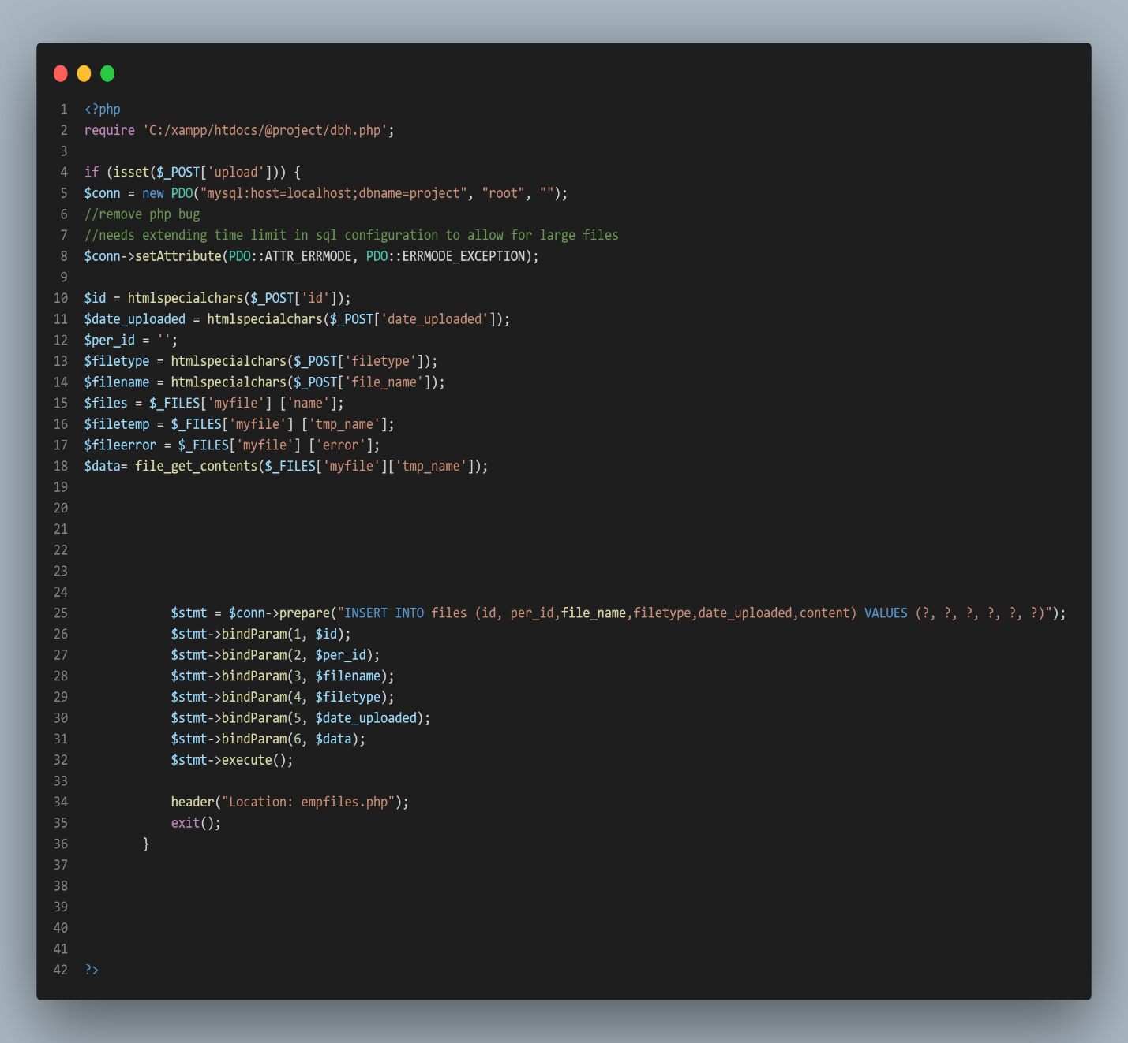

## **Developed system snapshots:**

### **System Homepage:**

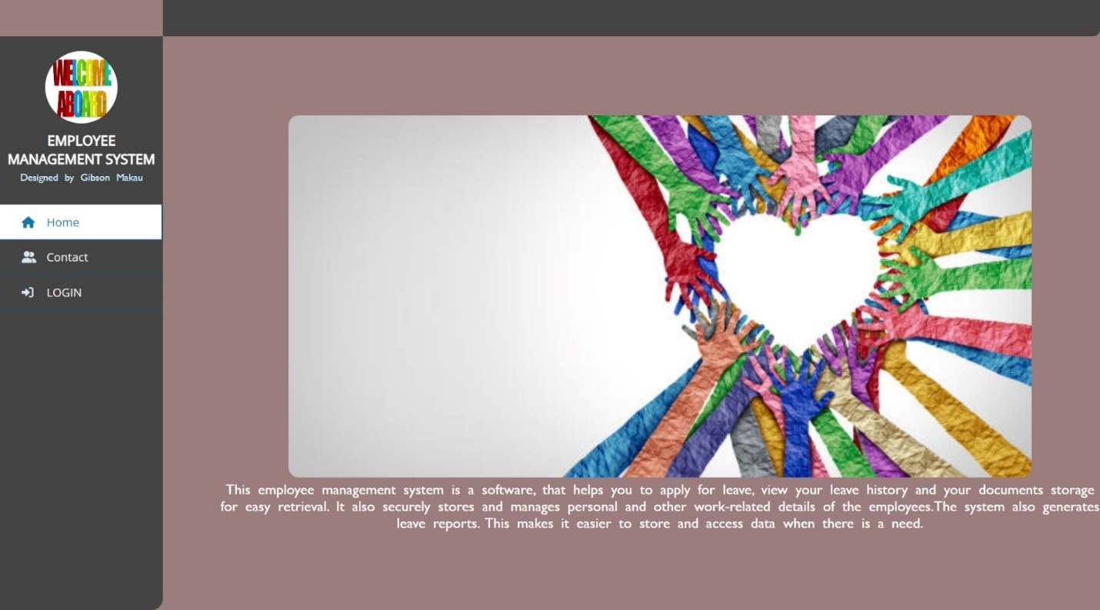

Figure 13:System Homepage

**System Contact page:**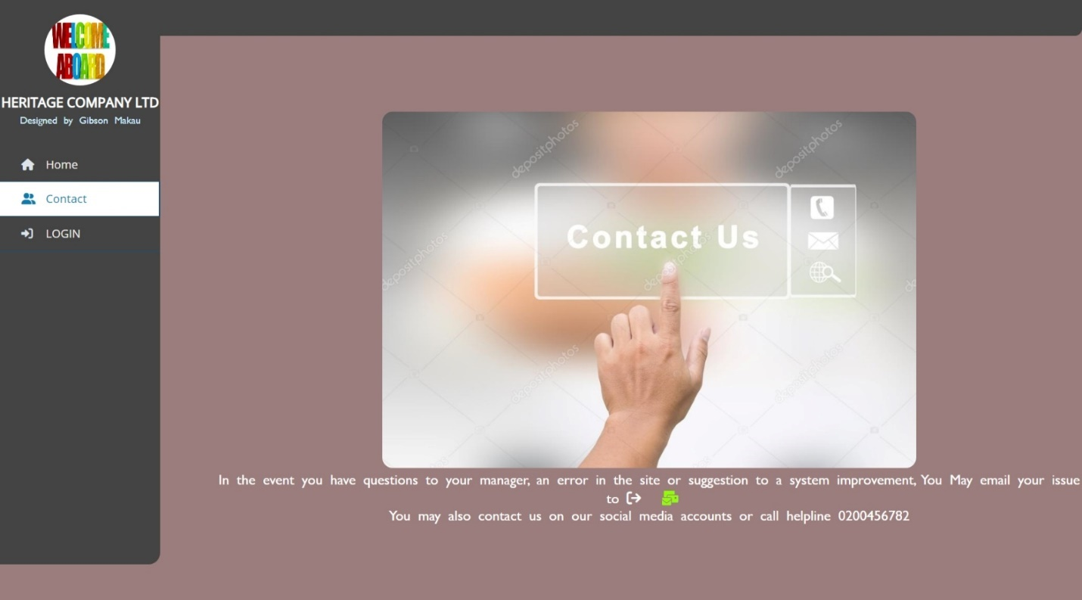

Figure 14: System contact.

**Employee login page:**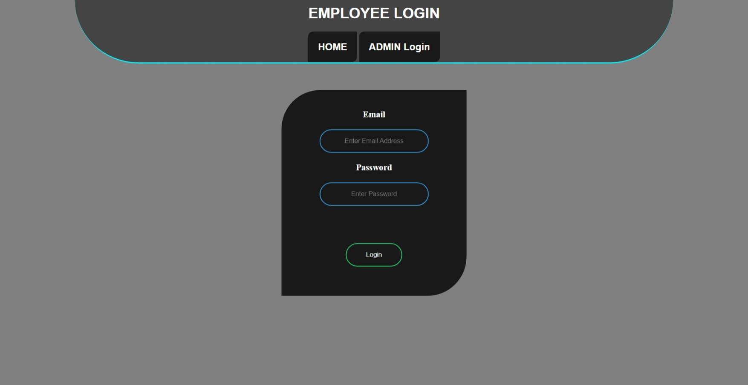

Figure 15: Employee login.

**Manager Login page**: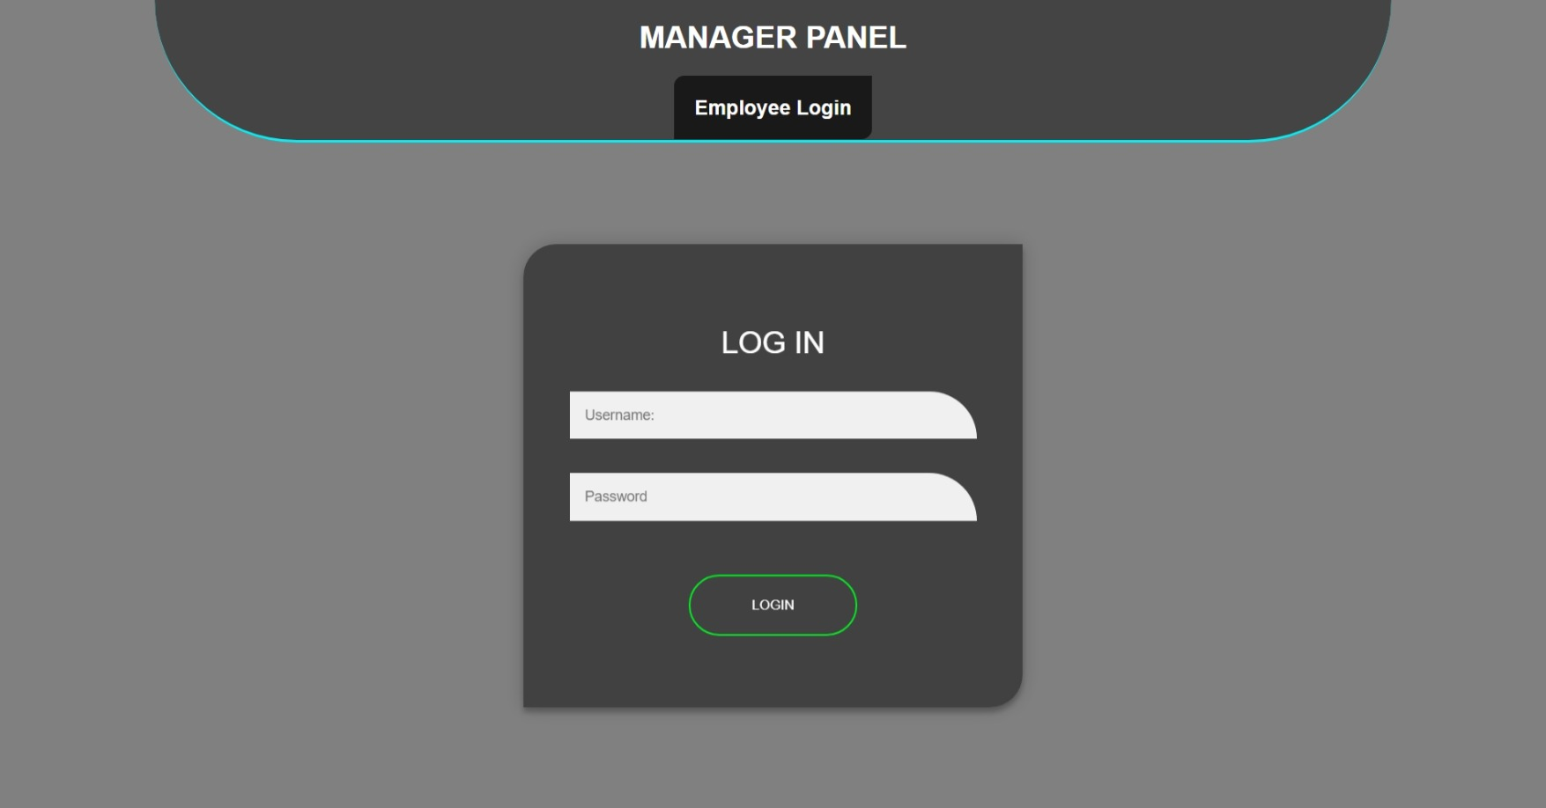

Figure 16: Manager login.

### **Employee User Interface:**

**Homepage:**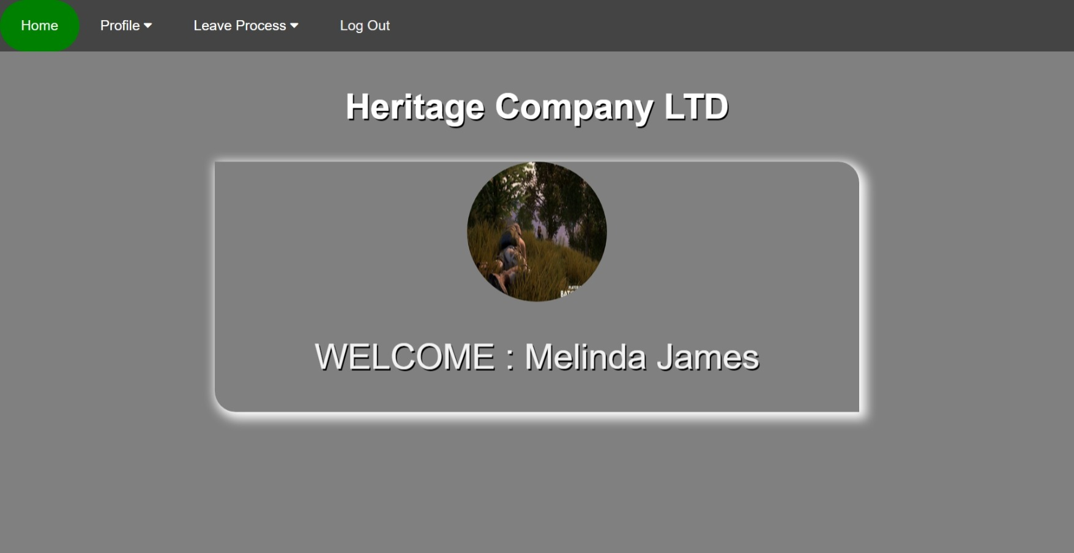

Figure 17: Employee login Homepage.

Profile page:

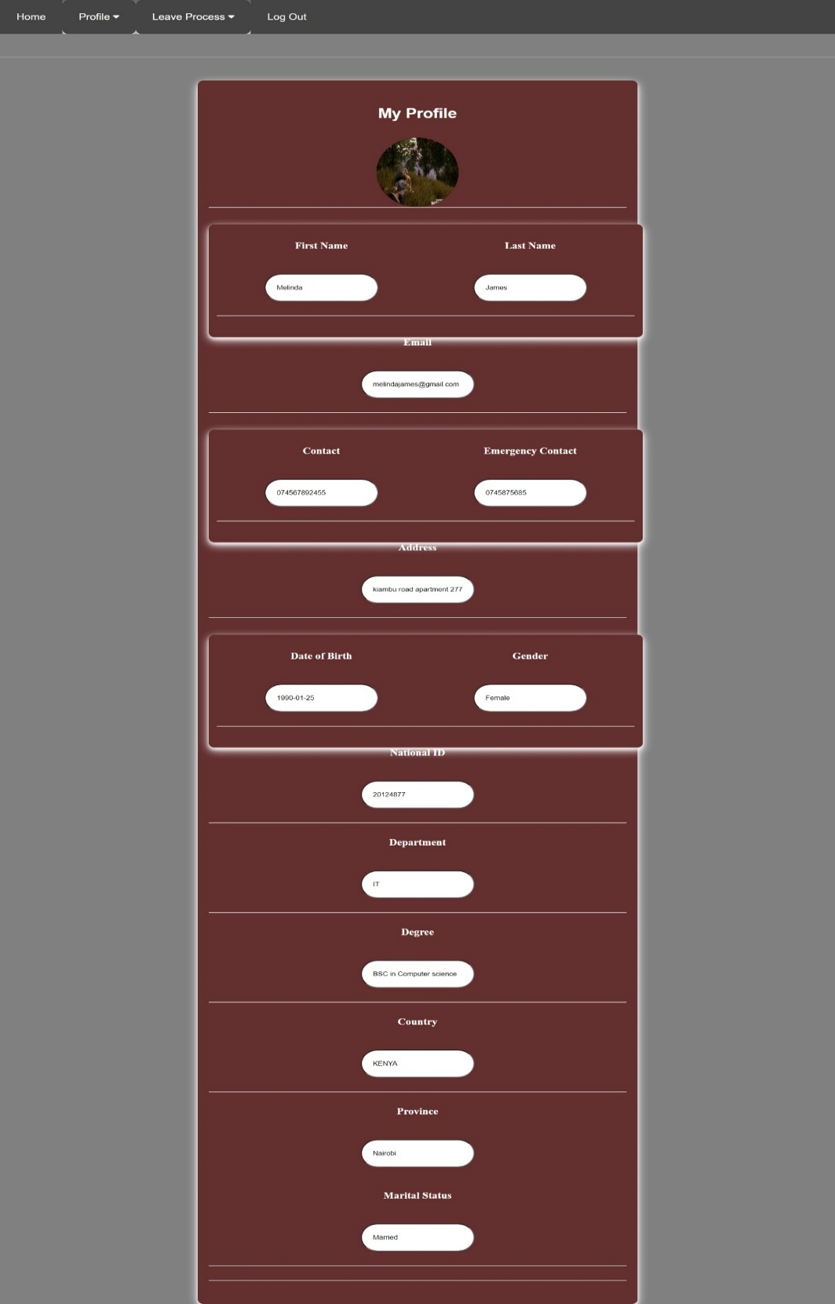

Figure 18: Employee myprofile.

**Profile update:**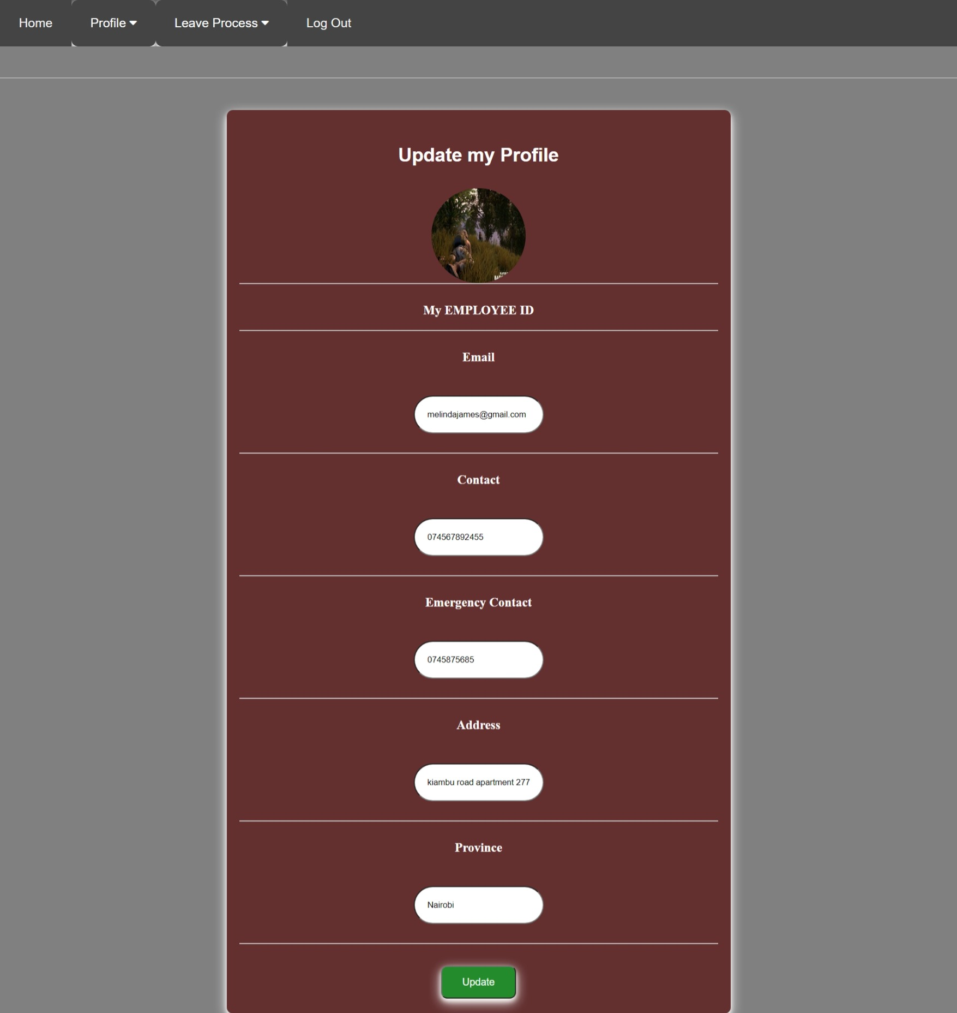

Figure 19: Employee update my profile .

**My documents:**

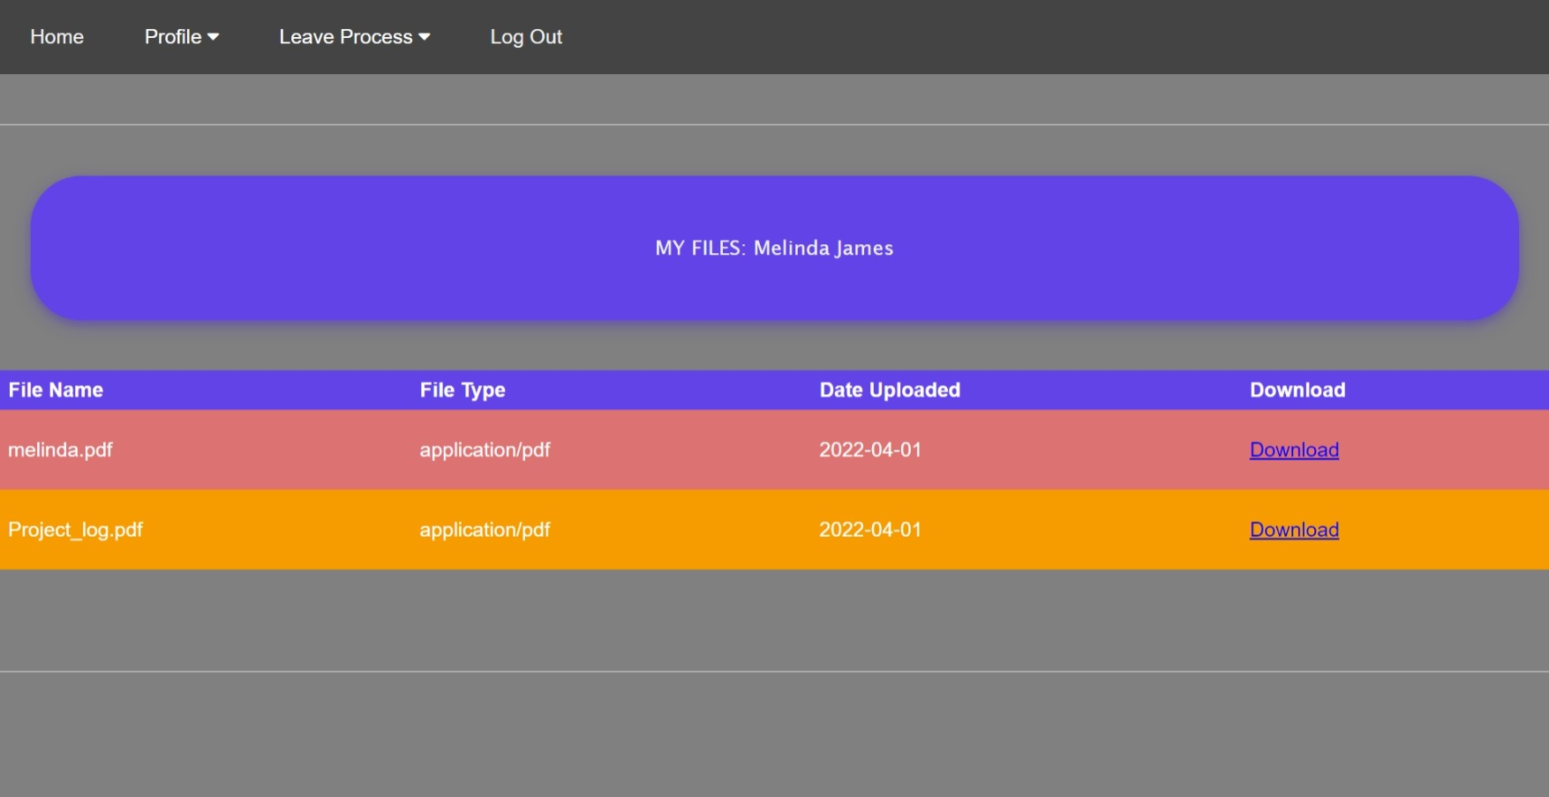

Figure 20: Employee download my documents .

**Change Password:**

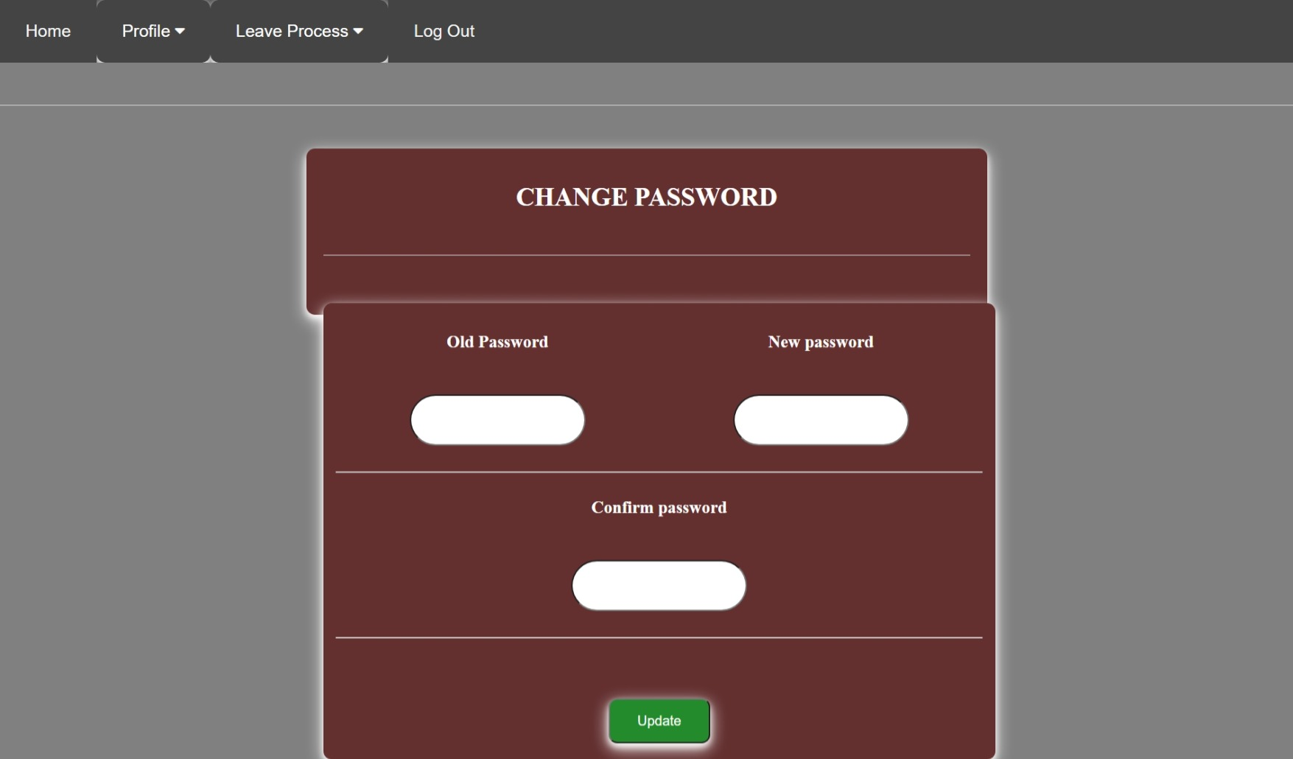

Figure 21:Employees’ change password .

**Apply leave:**

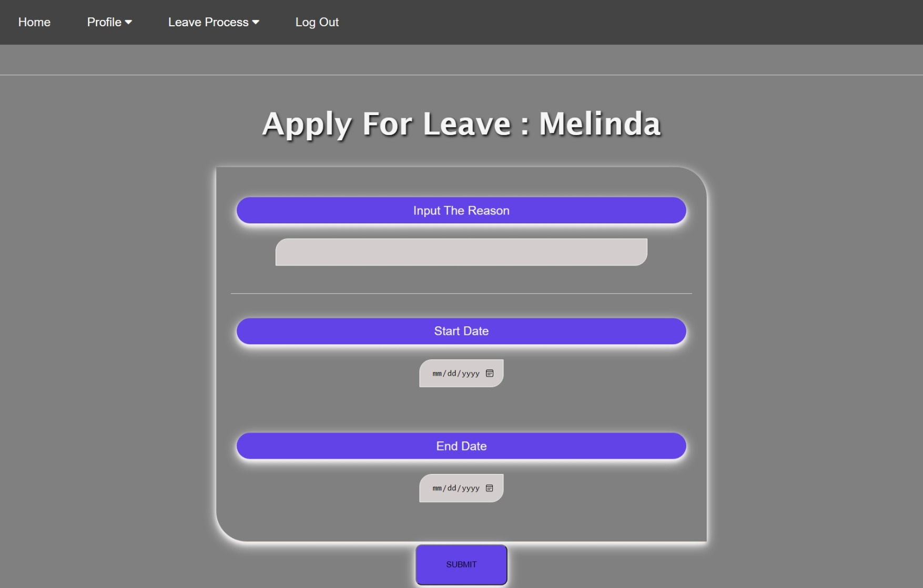

Figure 22: Employee Apply leave

Leave History: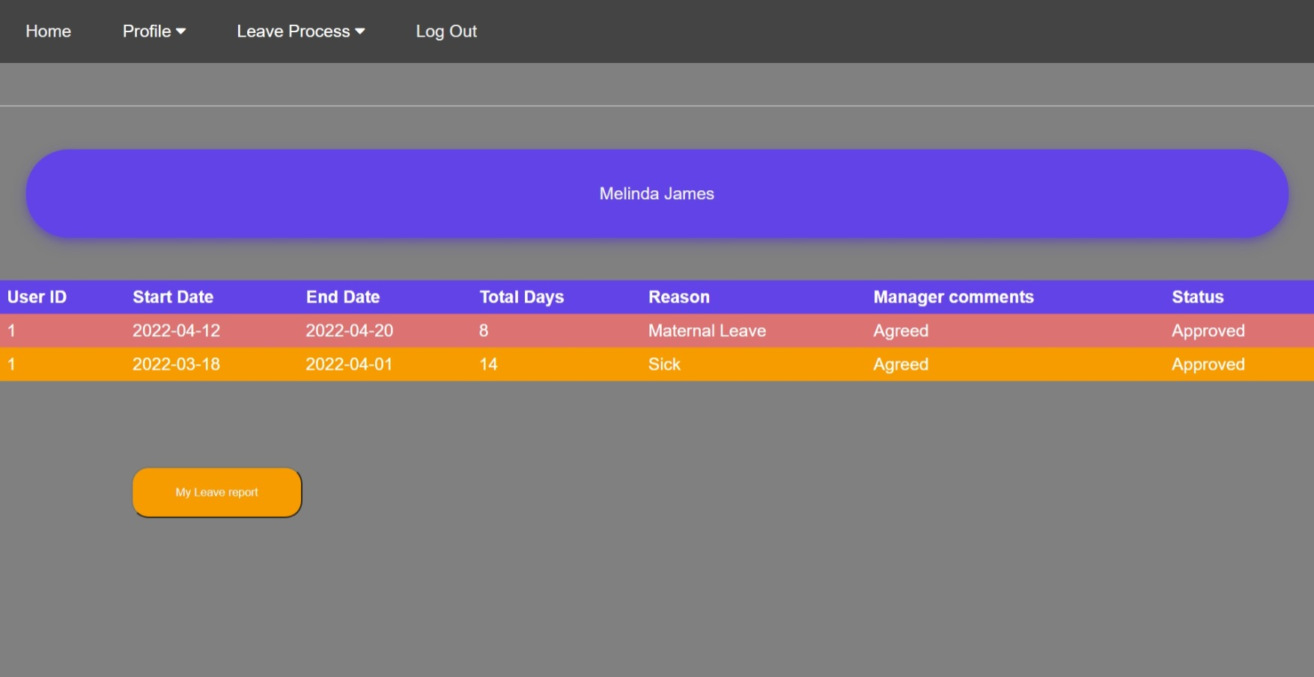Figure 23: Employee Leave History.

### **Manager User Interface:**

**Homepage:**

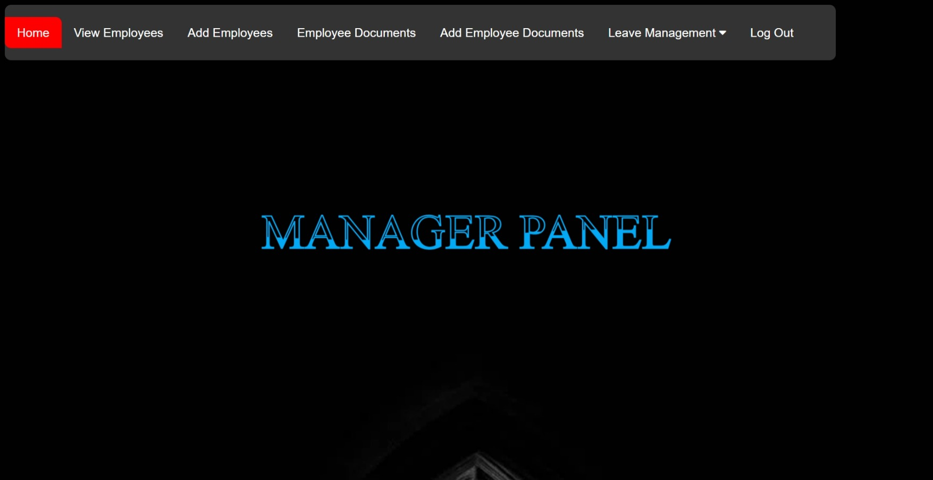Figure 24: Manager Login homepage.

**View employees:**

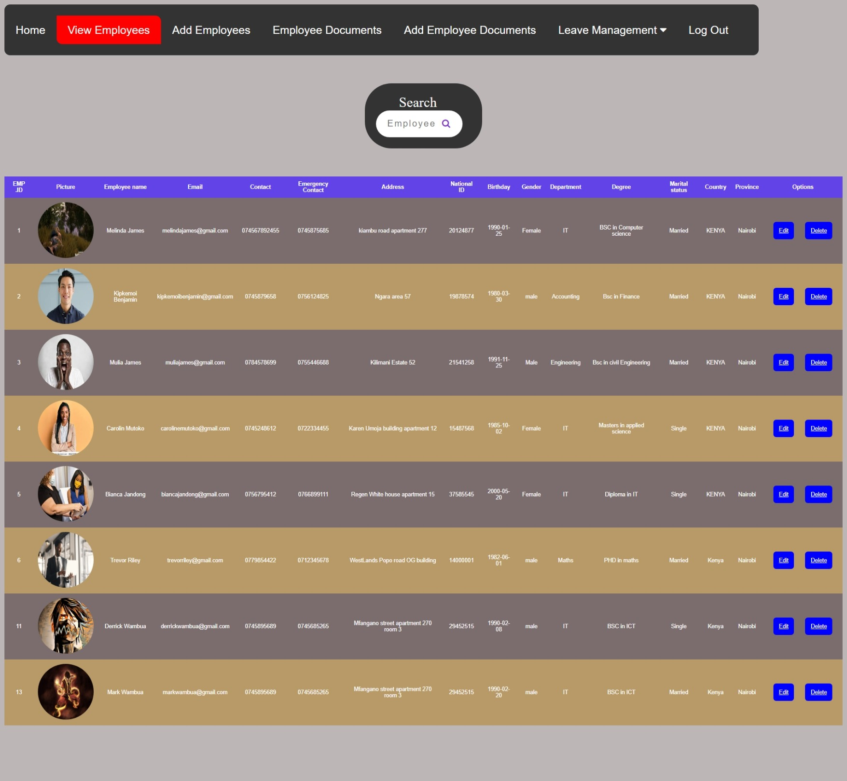Figure 25: Manager view employees.

**Edit an Employee:**

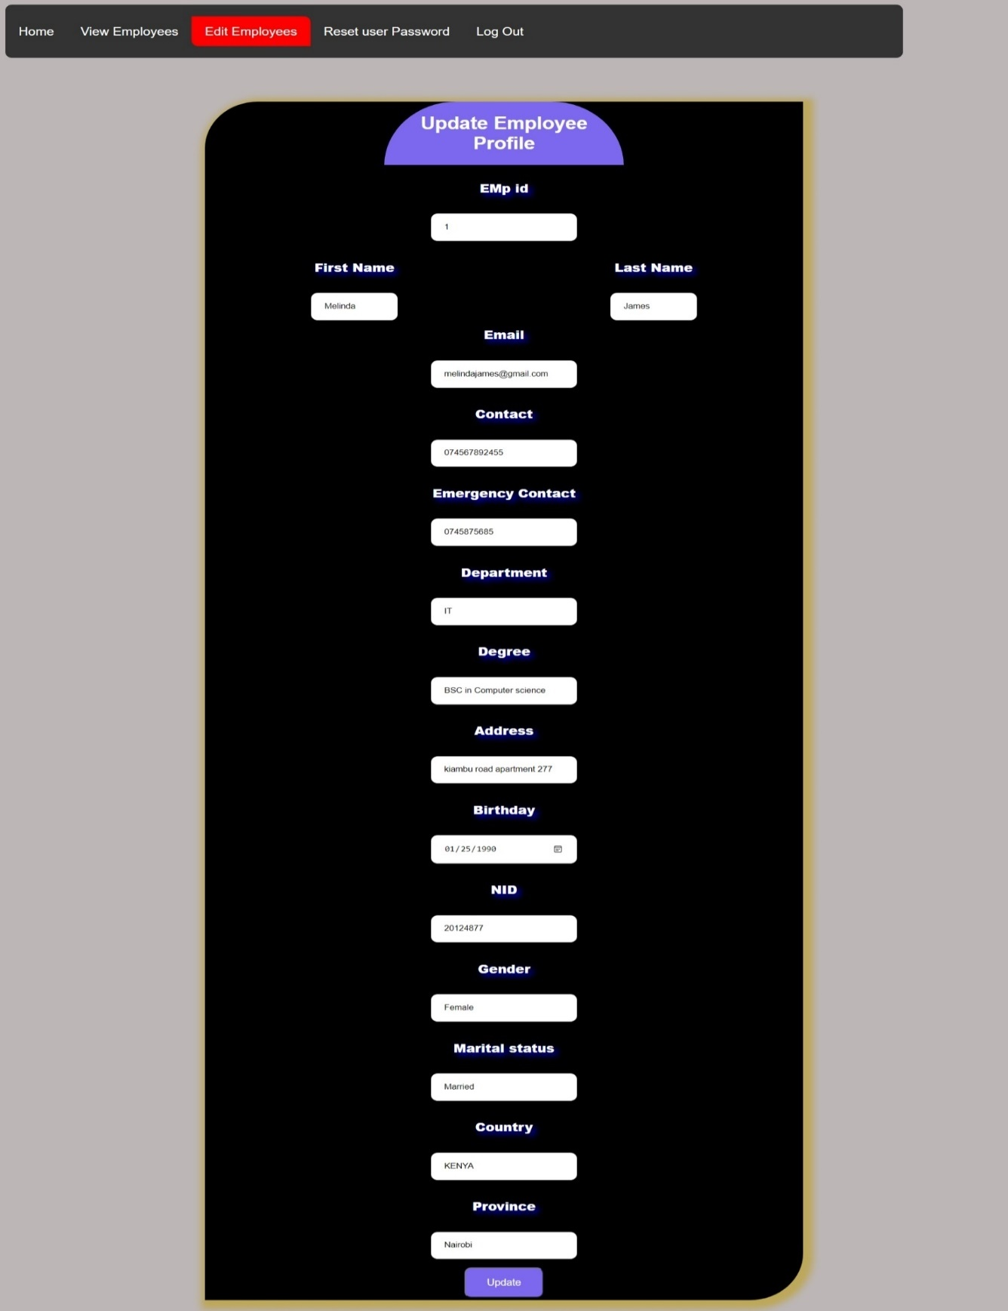

Figure 26: Manager Edit an employee information.

**Reset user password:**

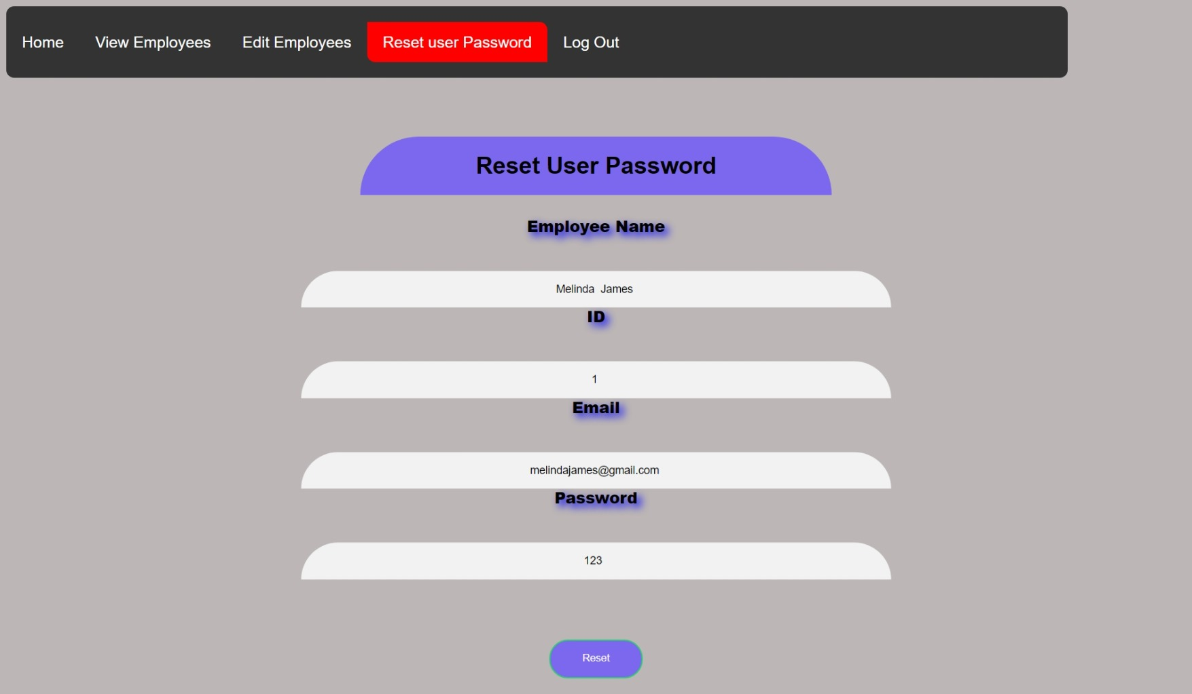Figure 27: Manager Reset employee login password.

**Add employee:**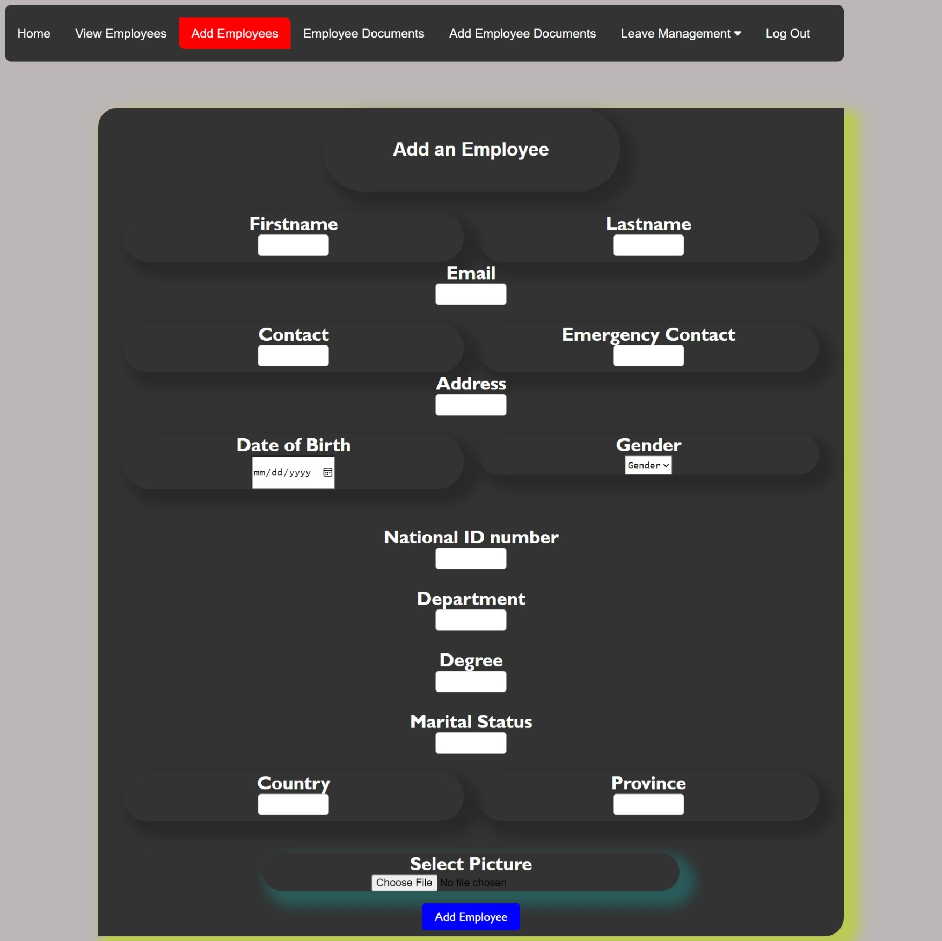

Figure 28: Manager add an employee.

**Employee Documents:**

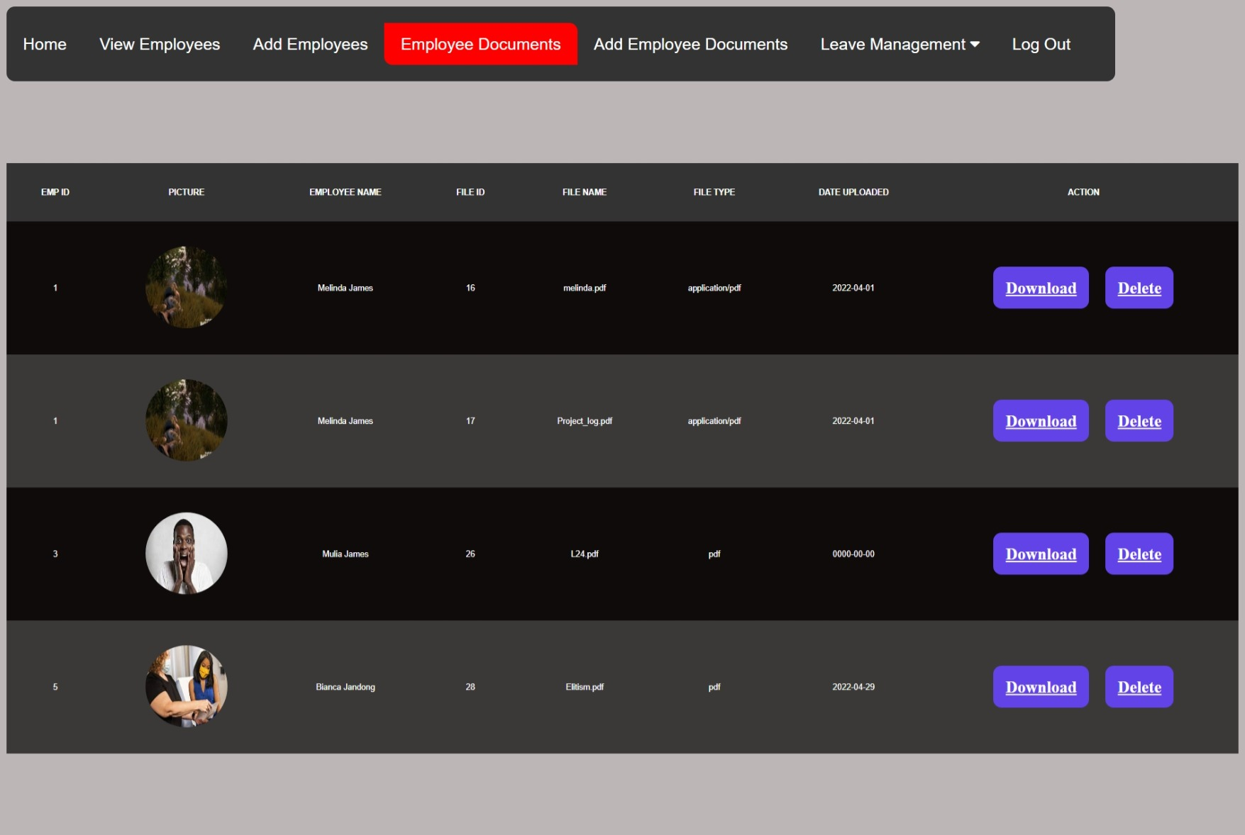

Figure 29: Manager employee documents

**Add employee Document:**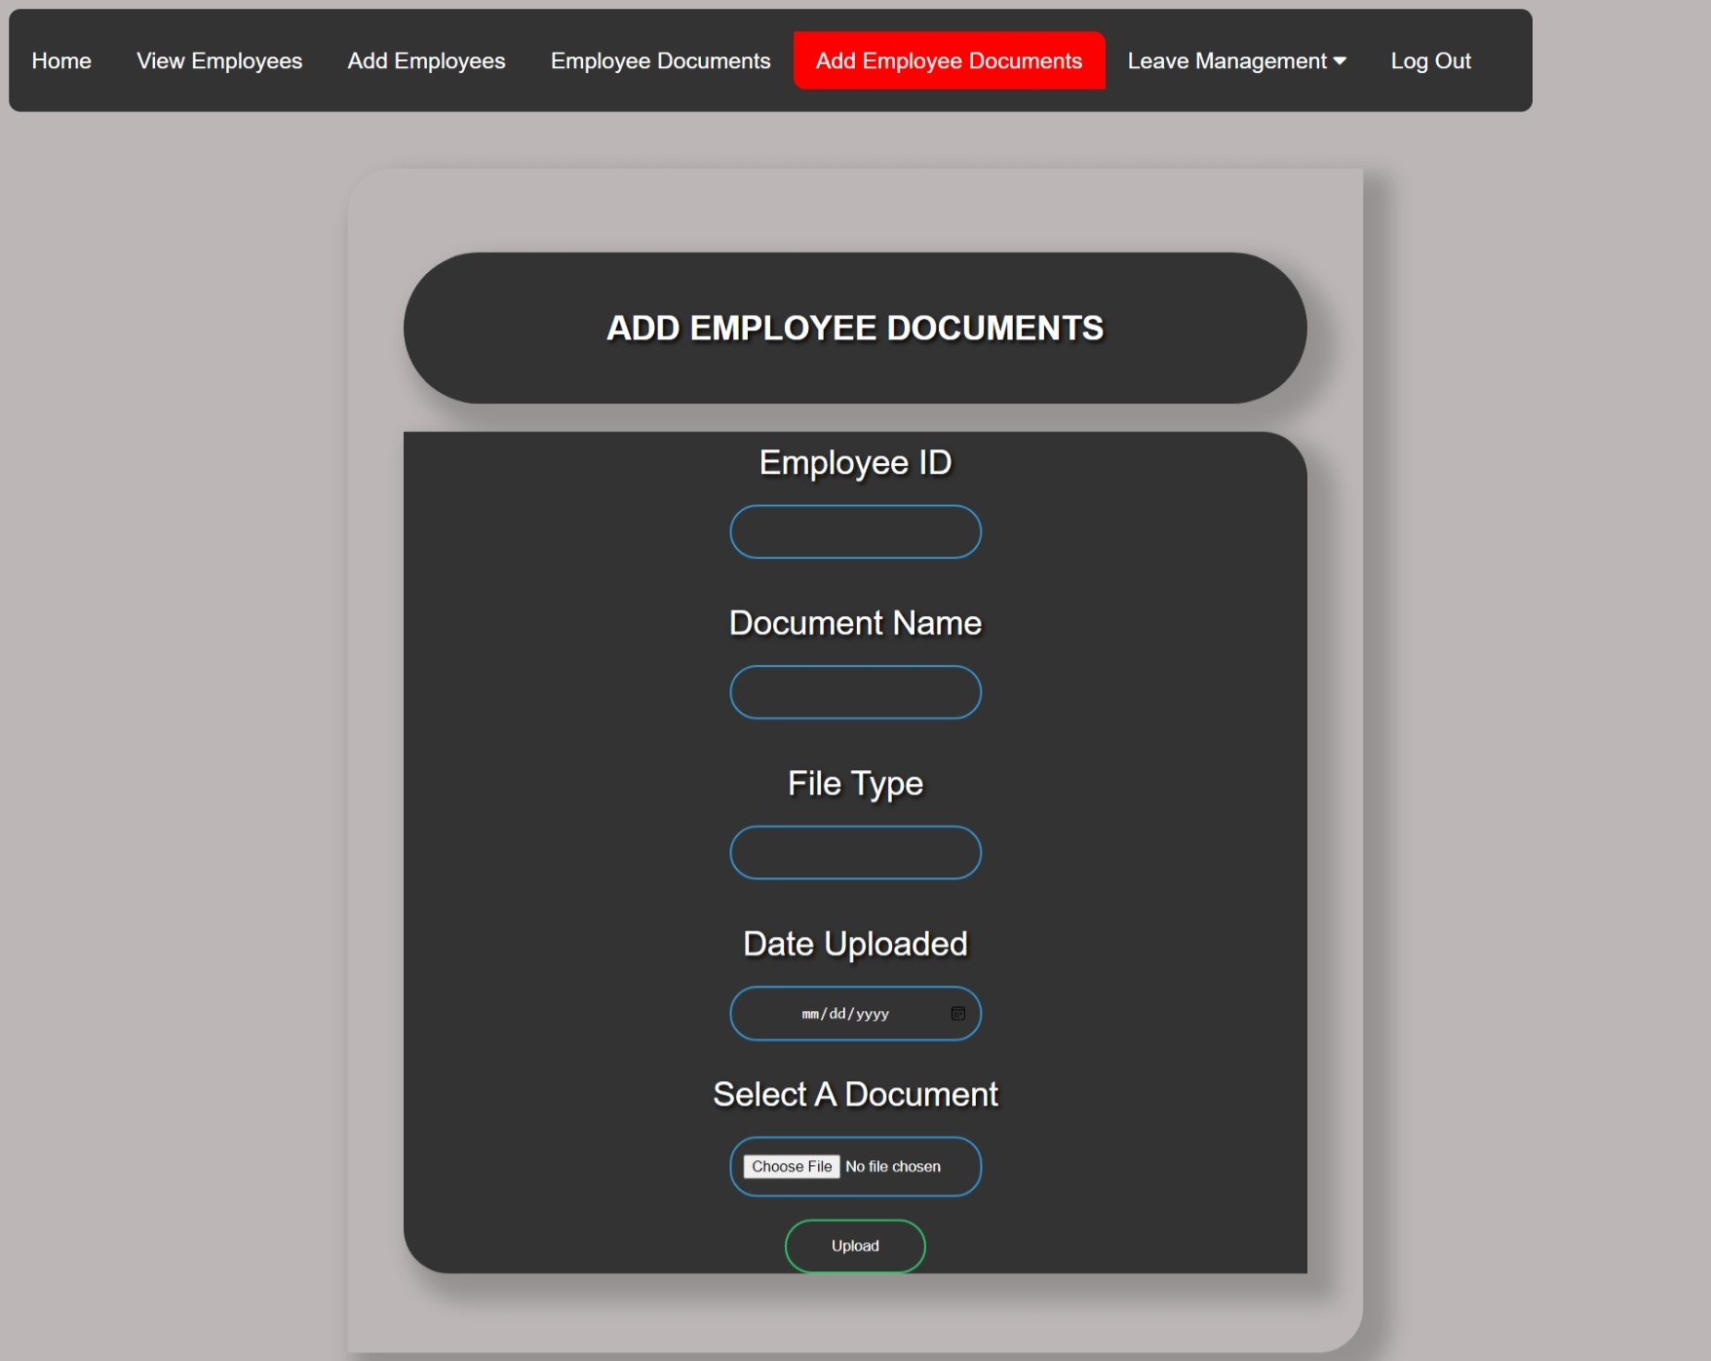

Figure 30: Manager add employee documents.

Pending Leaves: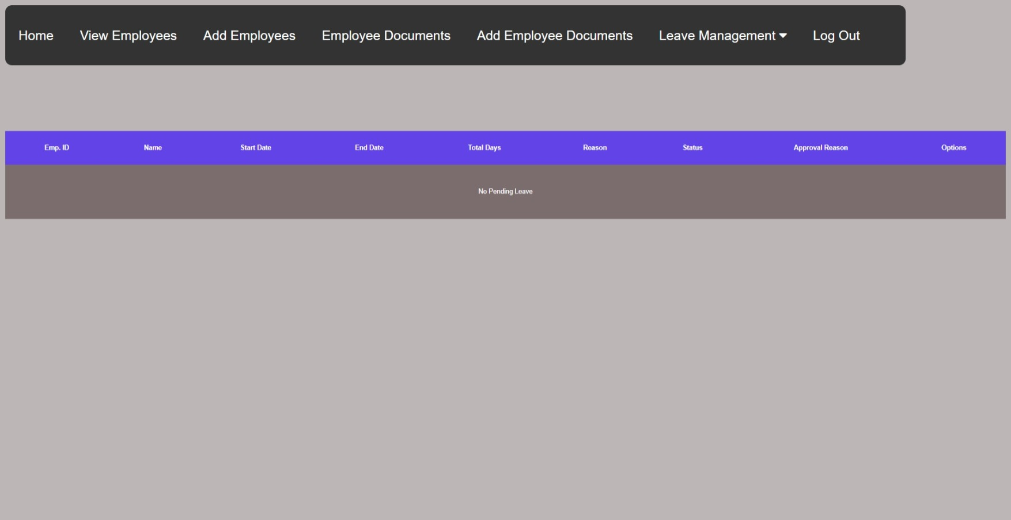

Figure 31: Manager view pending leaves.

Leave History: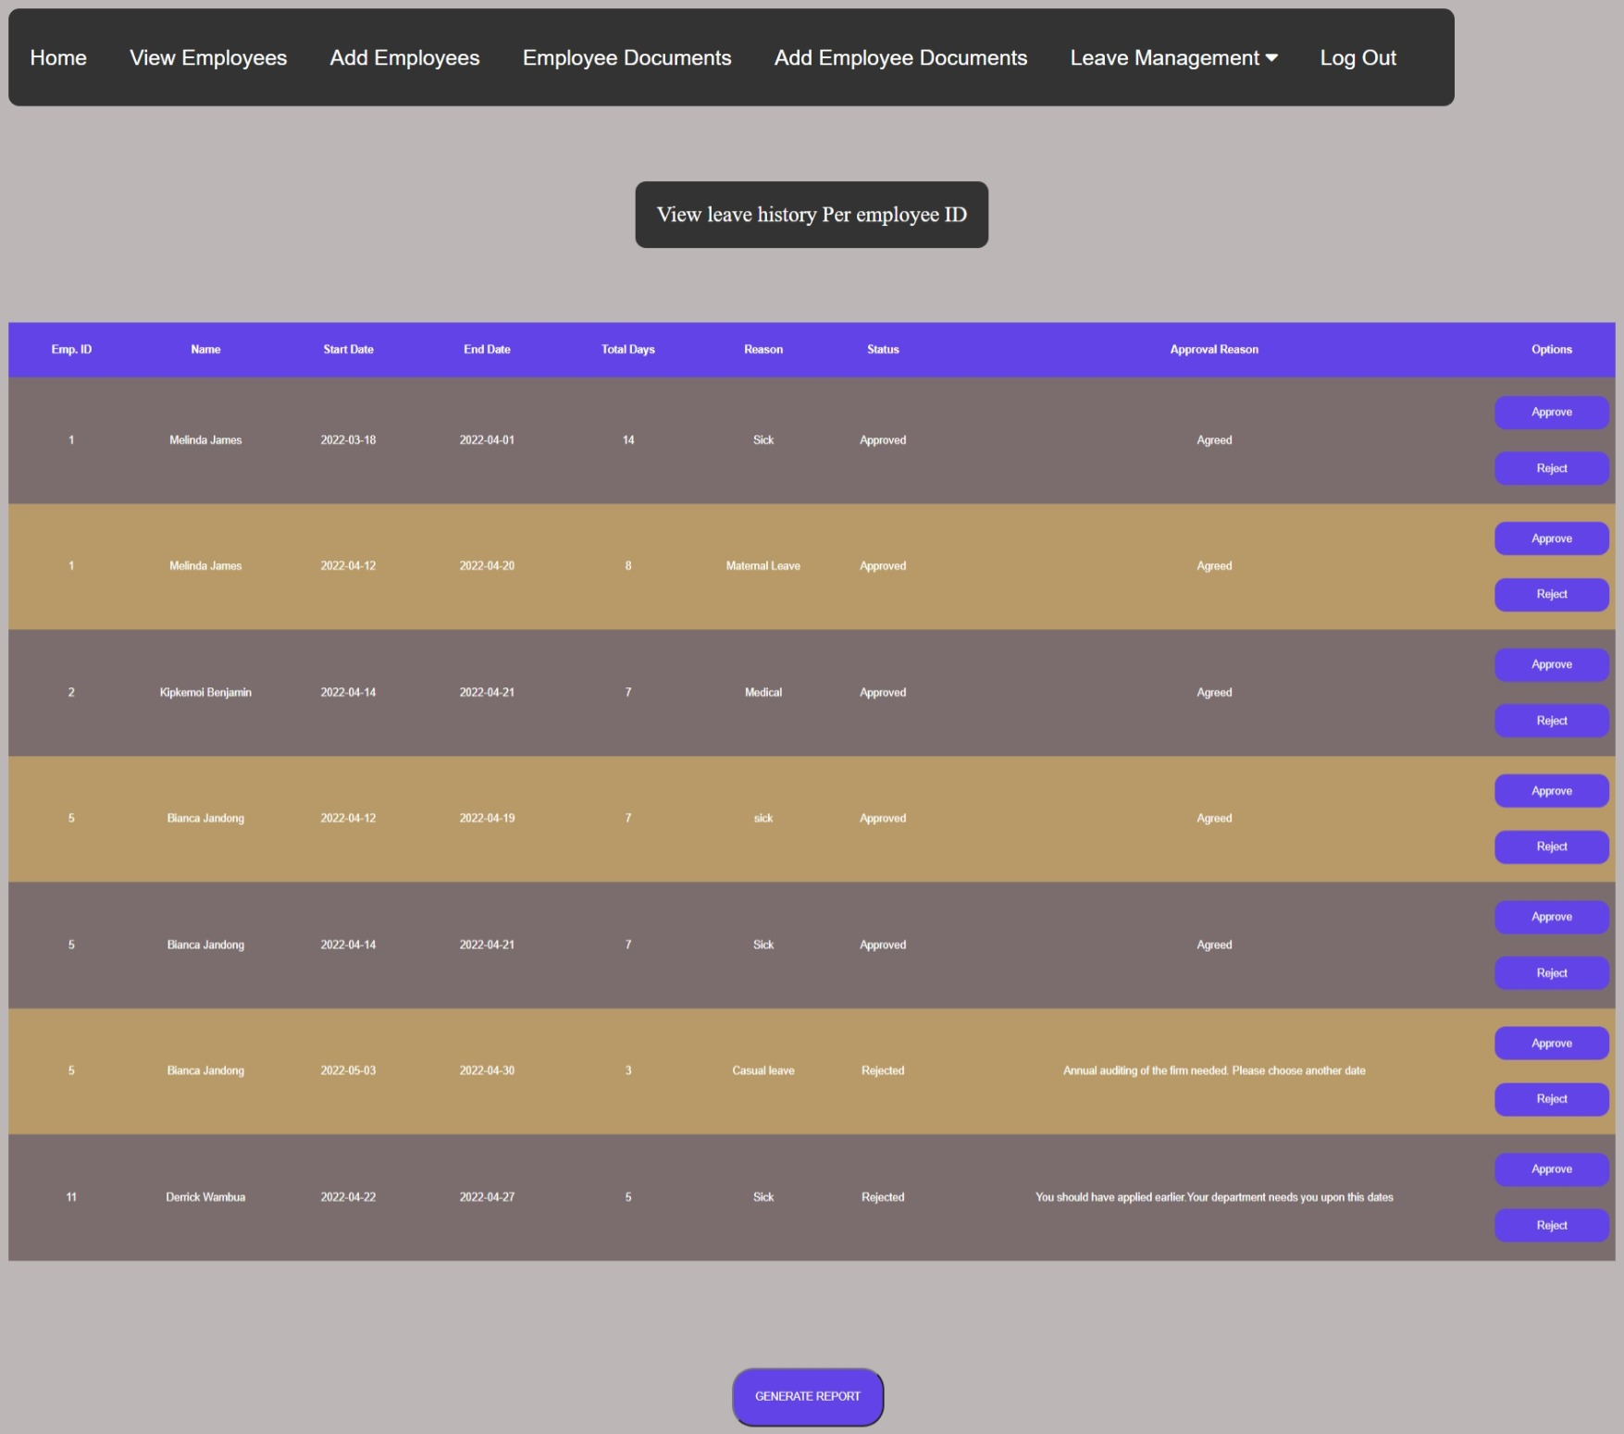Figure 32: Manager view leave history.

Leave History and report generation per Employee: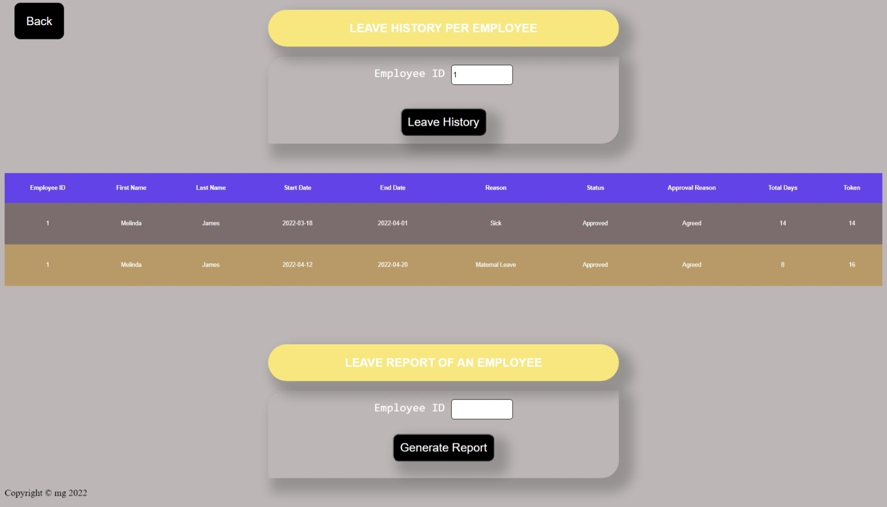Figure 33: Manager view leave history per employee.

Sample report.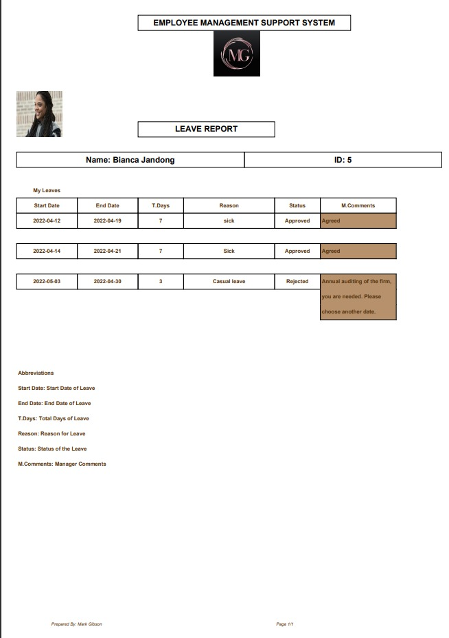

Figure 34: Sample leave report.